Year 12 ATAR
PHYSICS

Unit 4

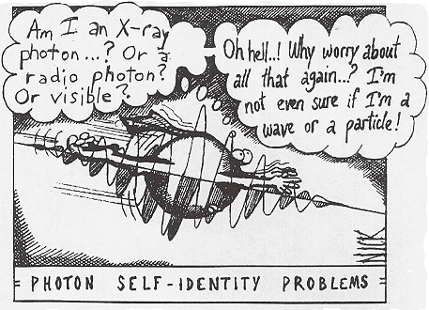

Wave Particle Duality and the Quantum Theory

Light exhibits many wave properties; however, it cannot only be modelled as a mechanical wave because it can travel through a vacuum.

WAVES:

- All waves, mechanical and electromagnetic, transfer energy from one place to another.

- A wave is a disturbance which progresses from one point in a medium to another, without the transport of matter. The characteristics of wave motion are:
- energy is needed to set up a wave.
- particles in the medium execute relatively small vibrations about their mean positions but suffer no permanent displacement.
- successive particles perform similar motions but slightly delayed in time (energy transferred as wave progresses).

- Mechanical waves are those which require a physical medium e.g. sound and water.

- Electromagnetic waves do not require a medium e.g. light, radio waves.

- A wave can be defined as a regular vibration (oscillation) which transfers energy while the medium (what the wave is made of) itself does not move from one place to another but rather vibrates about a fixed position.

TYPES OF WAVES

Transverse Waves
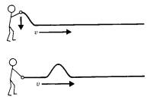
- Wave motion in which the particles of the medium vibrate perpendicular to the direction of energy transfer.
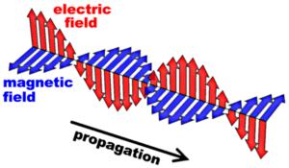

- Below is a transverse wave. On it mark the direction of travel for each of the medium particles indicated (one is done for you)
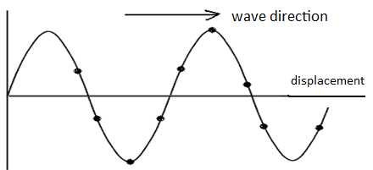

Longitudinal Waves
- Wave motion in which the particles vibrate left and right in the direction of energy transfer.

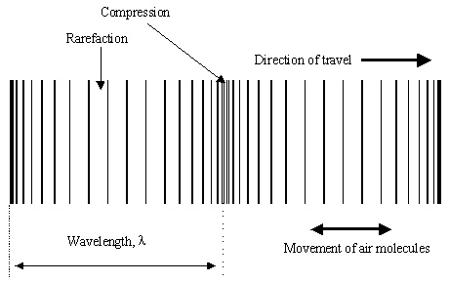
- Instead of peaks and troughs, a longitudinal wave is made up of regions of squashed up medium or higher pressure (called a compression) interspersed with regions of low pressure (called a rarefaction).

Representing Longitudinal Waves
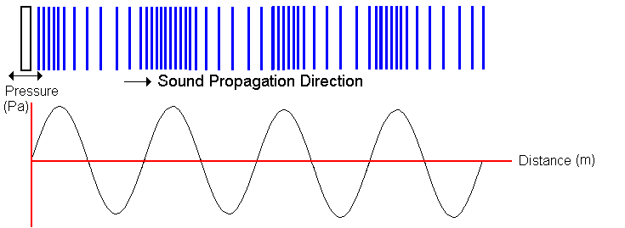
- The variation in pressure along a longitudinal sound wave is that of a sine wave as shown alongside.

- However longitudinal waves can also be represented by showing the variation of a single particle displacement from its mean or average location. This is quite a difficult concept to grasp. (
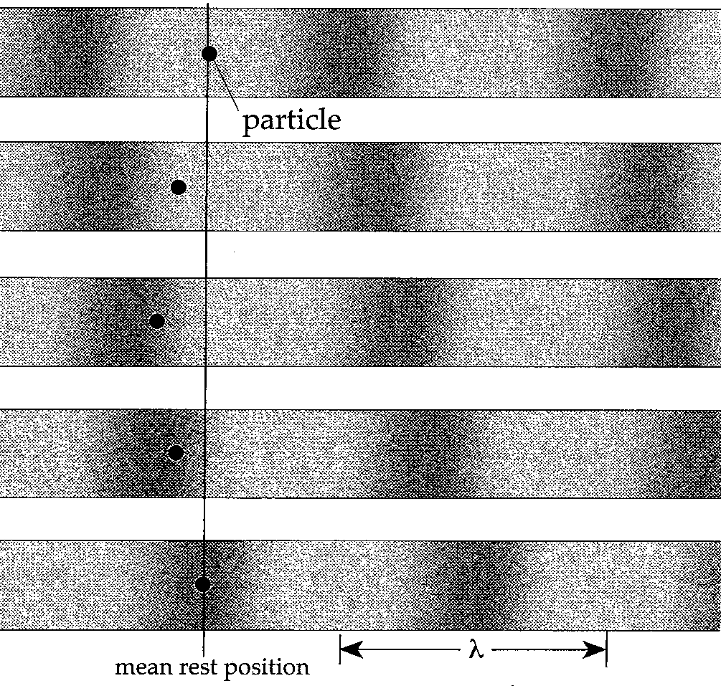
- In the diagram alongside, the motion of a single particle is recorded as a wave passes. Positive displacement is in the direction of the wave (R to L). The particle has zero displacement in the middle of lowest and highest pressure. It has maximum displacement half way between the two (middle strip).

- Consequently a graph to depict this variation in a particle displacement from its mean position must be 90⁰ or a ¼ of a wave shifted from a pressure variation wave.

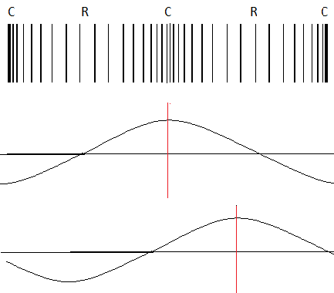
Compression wave

Pressure Wave

Displacement wave

- Water is actually a special wave type – a mixture of the two, but is considered transverse in this context.

- Explain how a mechanical wave is different from an electromagnetic wave and give examples of each.

- Explain the difference between the motion of the particles in transverse and longitudinal wave. Diagrams may help.

- What similarities and differences exist between longitudinal and transverse waves?

PERIODIC WAVES
- Disturbances which are single and non-repeating are called pulses.

- Disturbances which are repeated on a regular basis are termed periodic waves.

- The simplest form of vibratory motion is simple harmonic motion (SHM). The oscillations of a pendulum and the vibration of a single particle in a wave motion are examples of SHM.

- A particle vibrating with SHM has the following characteristics:
- it vibrates about an equilibrium position.
- at maximum displacement, velocity equals zero.
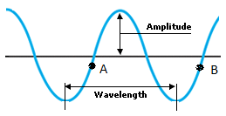
- at zero displacement, velocity is a maximum.

TERMINOLOGY
Displacement (s): the distance from equilibrium position
Amplitude: the maximum displacement of the wave
Phase: the position and motion at any instant –
points A and B are in phase.
Period (T) time taken for one complete wave cycle
Frequency (f) number of cycles per second (called pitch in music)
Wavelength (λ) the distance between two consecutive points in the same phase of wave.
Wave velocity (v): the velocity of the disturbance or wave through the medium.
Compression: maximum forward displacement of particle } associated with
(high pressure region) } longitudinal
Rarefaction: maximum reverse displacement of particles } waves
(low pressure area) }
Crest: maximum vertical (upward) displacement of particles } associated with
Trough: maximum vertical (downwards) displacement of } transverse
particles } waves

WAVE GRAPHS.
- A wave can be displayed on a graph as shown below:

- Displacement /distance graph -
This graph shows wavelength and amplitude
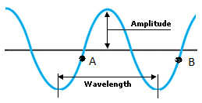
+

Displacement

-
shows many particles -
as if a still picture have been taken of the wave

Displacement

- Displacement /time graph Your teacher will draw this graph for you to copy.
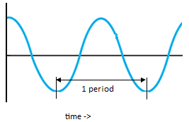
This graph shows the period of a wave
+

Displacement

-

shows one particle only -
as if a video has been
taken of the particle

- Explain why a different type of information is conveyed by a displacement-time graph in comparison with a displacement-distance graph.

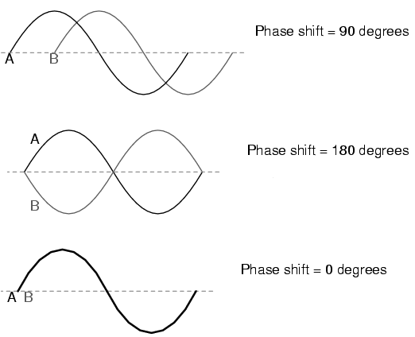

Phase Difference

- Two waves are ‘in phase’ if their crests and troughs occur simultaneously. If they are not ‘in phase’, the difference is expressed in degrees.

- What is the phase difference between the following pairs of points on the transverse wave below?
(a) A & D (b) B & E (c) G & H (d) A & E (e) B & H

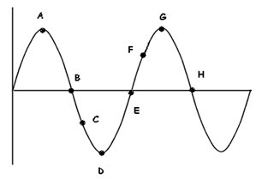


- A fisherman counts 5 waves passing his anchored boat each 20 seconds (or frequency = ¼ wave sec⁻¹) . He also notes that a wavelength is 2m long.
Calculate the wave velocity.

- Radio 96FM transmits radio waves at a frequency of 96.1MHz (at a velocity of 3.0 x 10⁸ ms⁻¹) of course.

a) How long are the waves?

b) What is the wave period?

WAVE FRONT
- A wave front represents all particles in the medium which are in the same phase, ie. all the crests (or troughs) or all the compressions (or rarefactions).

- A ray is a line drawn perpendicular to the wave fronts showing the direction of propagation. Each successive wave front is a wavelength apart.
ray

wave fronts

PP 7.1 p 232-4

A wave model explains a wide range of light-related phenomena, including reflection, refraction, dispersion, diffraction and interference; a transverse wave model is required to explain polarisation

WAVE BEHAVIOUR
Reflection:

- All waves are reflected when they strike a barrier in their path. They are reflected such that they obey the law of reflection: the angle of incidence = the angle of reflection.

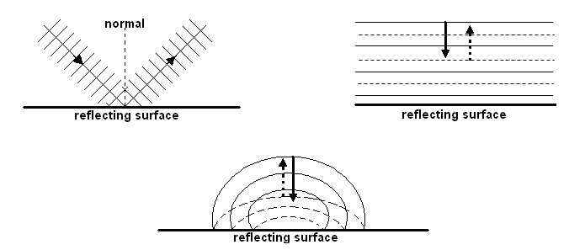
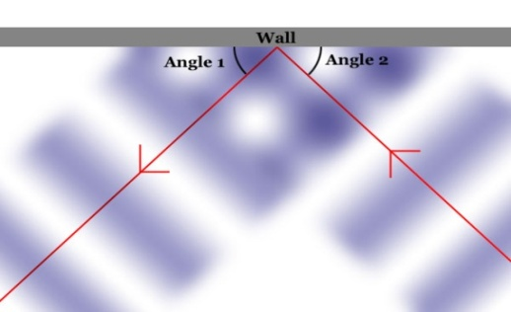

- As in all waves there is some absorption during reflection - i.e. not all energy is transmitted on.

Refraction:

- Refraction is due to a change in velocity as a wave passes from one medium to another with differing wave characteristics (e.g. more dense).

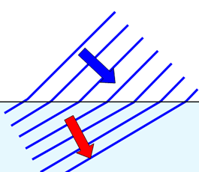
- The frequency of the wave remains unchanged but due to a change in velocity, the wavelength changes and a bending effect can be observed if the ray enters the new medium at any other angle than 90⁰.

Faster

Slower

Wave Formulas

where: n₁ is the refractive index of the first medium
n₂ is the refractive index of the second medium
i is the angle of incidence
n₁ sin i = n₂ sin r (Snell’s Law) r is the angle of refraction
v₁ = initial velocity of wave
v₂ = final velocity of wave
λ₁ = initial wavelength
λ₂ = final wavelength

- A sound wave of frequency 200Hz travelling at 345ms⁻¹ in air encounters a warmer layer of air where the velocity is 338ms⁻¹. What will the wavelength be in each layer? [Be aware that f stays constant during the transition]

- If the wave travels faster when it enters the new medium, it bends away from the normal e.g. sound waves travelling from air into water.

- If the wave travels slower when it enters the new medium, it bends towards the normal e.g. light waves travelling from air into water.
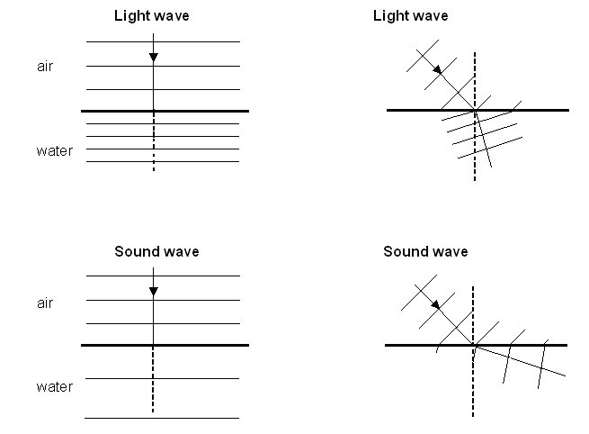
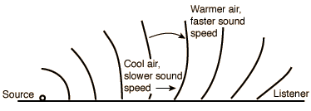
- The refraction of sound explains why sound can be heard over unusually long distances. It is probably unusual for sound to travel in straight paths in the atmosphere due to variation in density.
Density is not the only determining factor of speed of sound – elasticity of medium has an effect.

PP 7.1 p 237-40
Dispersion:

- When light enters a different medium it can be refracted. Different wavelengths of light are refracted by different amounts.

- Shorter wavelengths of light (violet) are slowed down more and are bent more than the longer wavelengths of light (red).

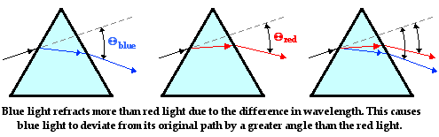

- White light is made up of all the colours of the rainbow ROYGBIV. When white light is separated into its colours, this is known as dispersion.
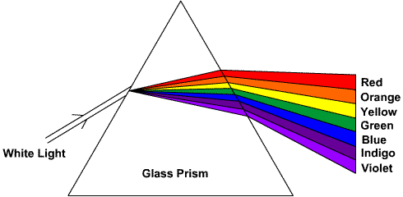

- Rainbows are the result of dispersion of light. White light enters water drops, refracts as it enters the drop, reflects of the back of the drop and refracts as it leaves the drop.

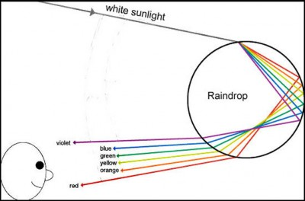

Diffraction:

- Diffraction is the bending of waves as they pass through an opening or around the edge or edges of an obstacle.

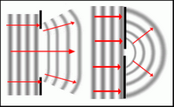
- The amount of bending depends on the opening. If the wavelength is about the same as the opening then maximum diffraction will occur.

- This helps to explain why you can hear someone through a door (wavelength of sound similar to width of a door) but you can’t see them (wavelength of light very small).

- In addition, higher frequency sound waves have shorter wavelengths sod they will diffract less than lower frequency sound waves as lower frequency sound waves have longer wavelengths.

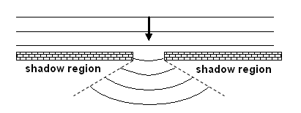
There is no movement in
the shadow region and
the size of the shadow
region is determined
by the width of the opening
and the wavelength. The
closer they are, the less
shadow region.
- Diffraction can also occur around corners. Since sound has a much longer wavelength than light, we are able to hear around corners, but not see around corners.

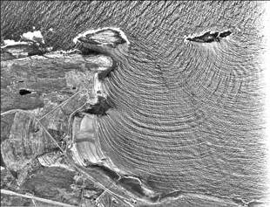
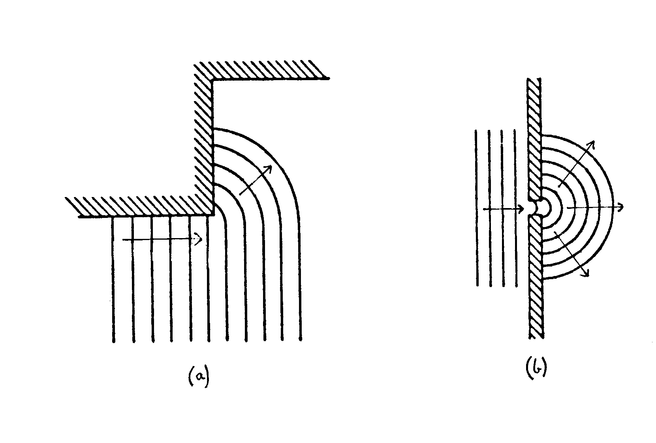

Polarisation:

- Light from a light source usually produces waves that are travelling in all directions. This is said to be unpolarised.

- Polarisation is the process of making all of the waves vibrate in the same direction.

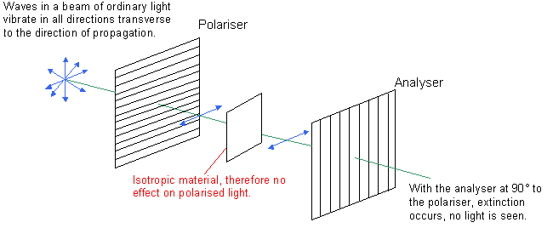

PP 7.1 p 241-6
A Summary of Wave Behaviour

Behaviour | Cause | Unchanged | Changed | Application
Reflection | change in direction as wave strikes a boundary | v, λ, f | direction | echoes and reverberation
Refraction | change in speed of wave as a result of change in density of a medium | f | direction, λ, v (Snell’s Law) | zones of silence
Diffraction | change in direction as a result of a wave passing through a gap or around an edge | v, λ, f | direction | hearing around corners and through gaps

WAVE EQUATIONS:

- The wave velocity is the velocity with which the disturbance moves through the medium. It is the product of the wavelength and the frequency.
v = fλ and T = where: v = wave velocity in m s⁻¹
f = frequency in Hz (s⁻¹)
λ = wavelength in m
T = period in s

- Carbon dioxide is heavier than air. An experiment is set up which has a layer of carbon dioxide in a large container with a layer of air on top. The speed of sound in the carbon dioxide is 270 m s⁻¹ and in the air, 340 m s⁻¹. A 450 Hz sound wave travelling through the air strikes the boundary between the two gases at an angle of 40⁰. Find the wavelength in each gas and then the angle of refraction into carbon dioxide.

- Look at the following wave.
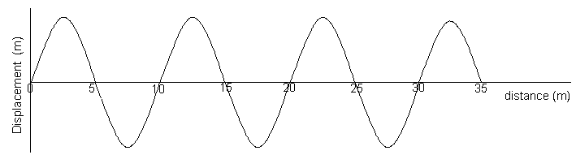

a. What is the wavelength of the wave above?
b. 10 waves pass every second. What is the frequency?
c. What is the time taken for 1 cycle (wave)? That is, what is the period?

d. Calculate the speed of the wave (velocity of the wave)?
e. On the axes below draw accurately the same wave as it would appear for the first 0.2 seconds.

- Look at the following wave that has a velocity of 3.0 x 10⁸ ms⁻¹. Calculate the frequency and then use the chart in your data sheet to determine what type of wave it is.

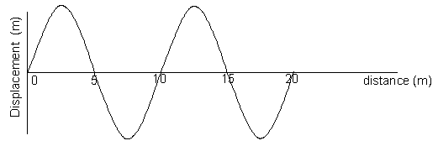

PP 7.1 Review p 247

QUESTION SET ONE: Waves and Wave Behaviour ANSWERS ON PAGE 56

- An umpire blows his whistle when he is at the opposite end of a football ground from you. Estimate the time delay between the moment you see the whistle being blown and when you hear it.

- a. What does the term “displacement” mean when applied to sound waves.
b. Sketch graphs of displacement versus time for a low pitch graph and a high pitched graph.

- Do sound waves diffract? If you wanted to try and demonstrate that your answer is correct, how would you try to do this? Include a diagram with your answer.

- Some examples of waves are sound, radio, water waves, and X-rays. Classify these as either mechanical or electromagnetic waves.

- A person fishing from jetty notices that the foam float on their fishing line gently bobs up and down as regular waves pass by. The person counts 13 full oscillations of the float in one minute. What is the period of the wave?

- An example of a longitudinal wave is ______ An example of a transverse wave is _________
Explain the difference between longitudinal and transverse wave.

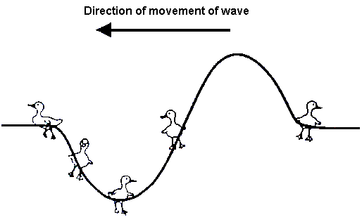
- Bridgette is watching some ducklings, which are paddling on a pond, when a wave approaches them. Use arrows to show direction of movement of each duckling at the instance shown on the diagram. If there is no movement, label “no-motion”.
- Draw a graph to illustrate amplitude and wavelength of a wave.
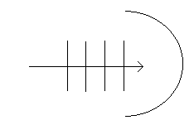

- Complete the following diagram to show reflection of sound from a circular reflector.

- On a calm summer evening the air near the ground is rather cool while higher up it is warmer. Sound travels faster in warm air. Using wave-front diagrams carefully show how refraction of sound can allow the noise from an aircraft to be heard quite clearly at some point far away.
v = f λ f = v/λ

Electromagnetic waves are transverse waves made up of mutually perpendicular, oscillating electric and magnetic fields.

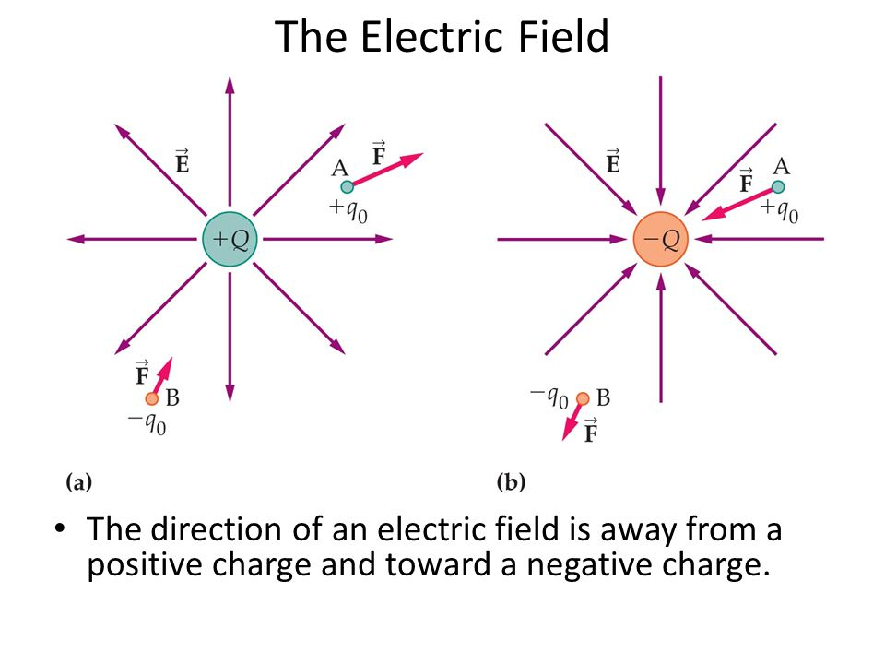
Electromagnetic Radiation
- The creation of all electromagnetic waves begins with a charged particle.
- This charged particle creates an electric field.
- This field can exert a force on other nearby charged particles.
- Positive charges accelerate in the direction of the field and negative charges accelerate in a direction opposite to the direction of the field.

- If a charged particle, like an electron, begins to move, it accelerates.
- As it oscillates, the charged particle creates ripples in its electric field.
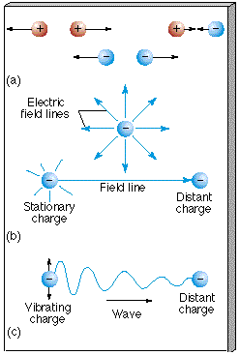

- A charge moving back and forth in a wire will create an oscillating electric field that propagates outwards.
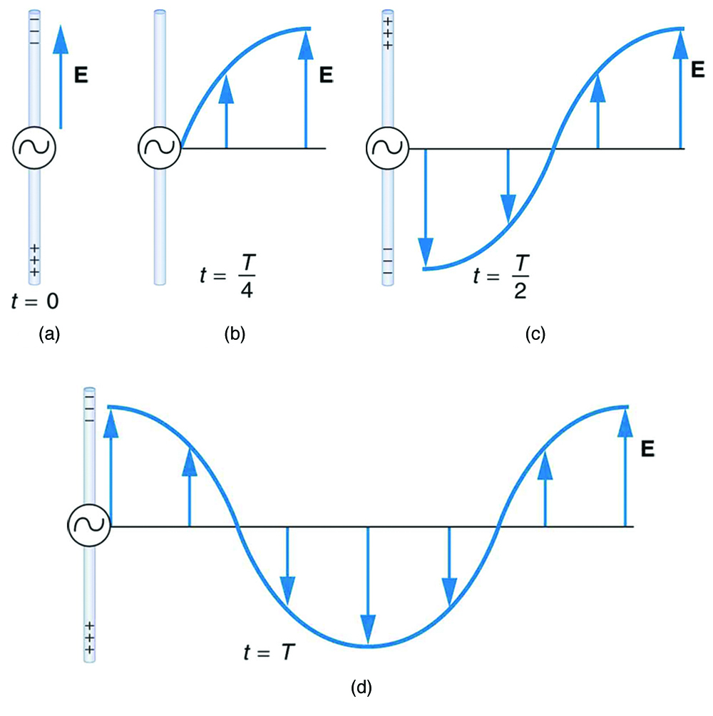


- A moving charged particle also produces a magnetic field. The current in the wire produces circular magnetic field lines. The magnetic field varies with the current and propagates away from the wire at the speed of light.

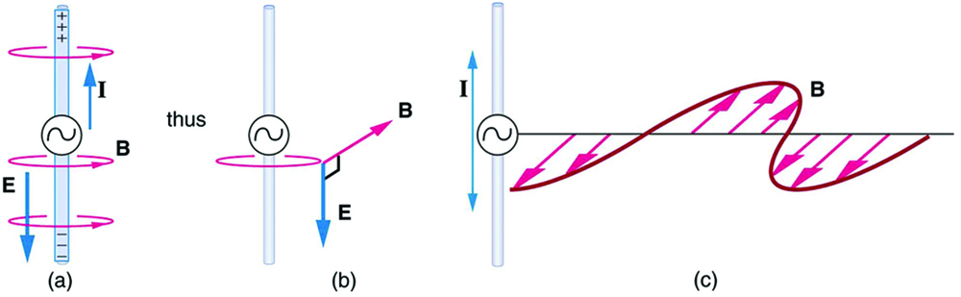

- Once in motion, the electric and magnetic fields created by a charged particle are self-perpetuating—time-dependent changes in one field (electric or magnetic) produce the other.
- This means that an electric field that oscillates as a function of time will produce a magnetic field, and a magnetic field that changes as a function of time will produce an electric field.
- Both electric and magnetic fields in an electromagnetic wave will fluctuate in time, one causing the other to change.
- This is why it is able to travel through a vacuum.
- An accelerating charged particle produces an electromagnetic (EM) wave. Electromagnetic waves are electric and magnetic fields traveling through empty space with the speed of light c.
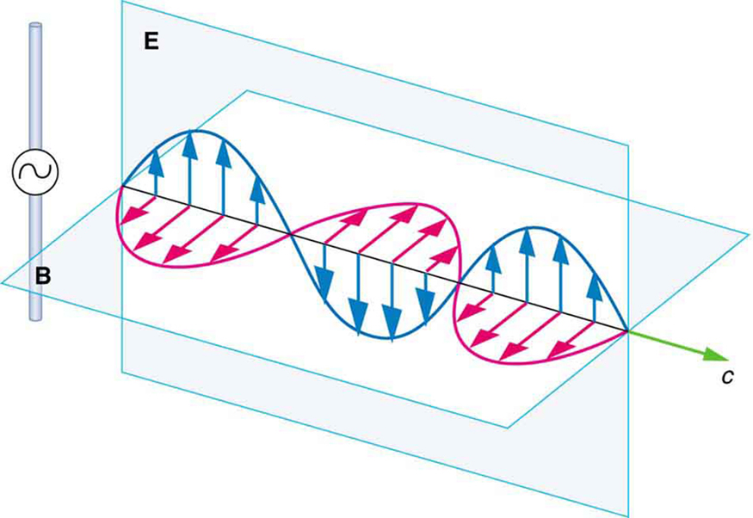

- A charged particle oscillating about an equilibrium position is an accelerating charged particle.
- If its frequency of oscillation is f, then it produces an electromagnetic wave with frequency of f. The wavelength λ of this wave is given by λ = c/f.

- Different types of oscillations produce different types of electromagnetic radiation depending on their frequency (or wavelength).
- All electromagnetic radiation travels at the speed of light (3.0 x 10⁸ ms⁻¹) and in straight lines.

- Electromagnetic waves transport energy through space. This energy can be delivered to charged particles a large distance away from the source.

- Accelerating charges produce changing electric and magnetic fields. Changing electric fields produce magnetic fields and changing magnetic fields produce electric fields.
- This interplay between induced electric and magnetic fields leads to propagating electromagnetic waves.
- Electromagnetic waves can propagate through free space. They do not need a medium.

Properties Of Electromagnetic Radiation
- EM Radiation travels in straight lines. It can travel through a vacuum or transparent media. It travel away from source in 3 dimensional space.
- Speed of EM radiation in a vacuum is same as the speed of light – 3.00 x 10⁸ ms⁻¹.
- It travels at different speeds in different medium, the denser the medium the slower the wave moves.
- EMR has both wave-like and particle-like in nature – dual nature of electromagnetic radiation.
- Particles travel in wave-like motion. Work by Huygens (1629 – 1695) showed wave-like properties (reflection, refraction, diffraction). Wave-like properties also shown by work of Thomas Young (double slit experiment) which showed interference patterns producing light and dark areas on screen.
- Work by Einstein (1879 – 1955) showed particle properties – photoelectric effect. Light can cause electrons to be ejected from some metal surfaces. Particle-like also shown by spectra.
- As EMR is wave-like, we can use wave formula in calculations; v = fλ
- Low energy radiation e.g. radio waves, are more wave-like while high energy e.g. gamma rays are more particle-like. High energy waves are also ionizing.
- Bundles of light energy (or any electromagnetic wave) known as PHOTONS, energy each particles contains is called a QUANTUM

Major Regions of Electromagnetic Spectrum
wavelength increasing
Cosmic Rays | Gamma Rays | X-rays | Ultra-violet | Visible  light  violet - red | Infra-red | Micro-waves | Radio waves
frequency and energy decreasing
Colour | Wavelength (nm)
red | 750 – 620
orange | 620 – 590
yellow | 590 – 580
green | 580 – 500
blue | 500 – 460
indigo | 460 – 450
violet | 450 – 400

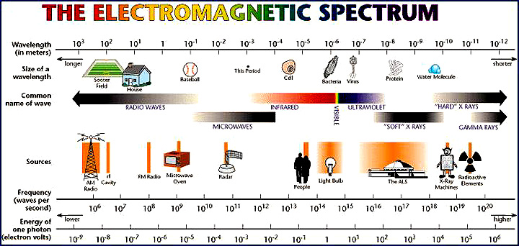

WSG 103-6
Oscillating charges produce electromagnetic waves of the same frequency as the oscillation; electromagnetic waves cause charges to oscillate at the frequency of the wave.

- The EM wave propagates because the electric field recreates the magnetic field and the magnetic field recreates the electric field.

- All EMR’s are created by oscillating charged particles. The frequency of oscillation of the charged particles will determine the frequency of the wave that is created.

- Radio waves are the low frequency, long wavelength part of the EM spectrum. They can be created by radio antennae.

- Typically, an antenna consists of an arrangement of metallic conductors, electrically connected to the receiver or transmitter.

- An oscillating voltage applied to the antenna by a transmitter makes the charges in the antenna vibrate up and down – accelerate and decelerate.
- This oscillating current of electrons will create an oscillating magnetic field around the antenna elements, while the charge of the electrons also creates an oscillating electric field along the elements.

- These fields radiate away from the antenna into space as a moving transverse electromagnetic wave.
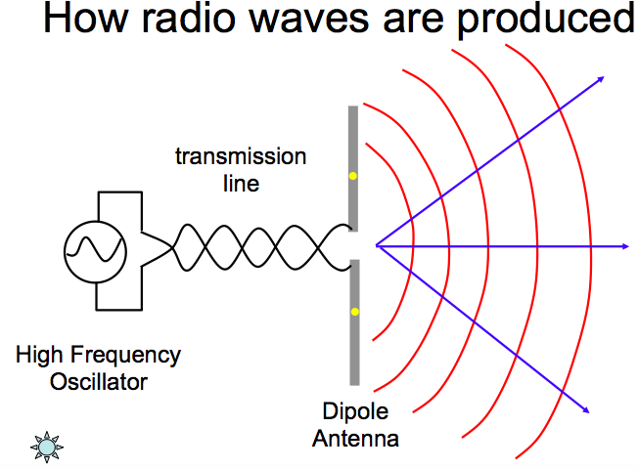
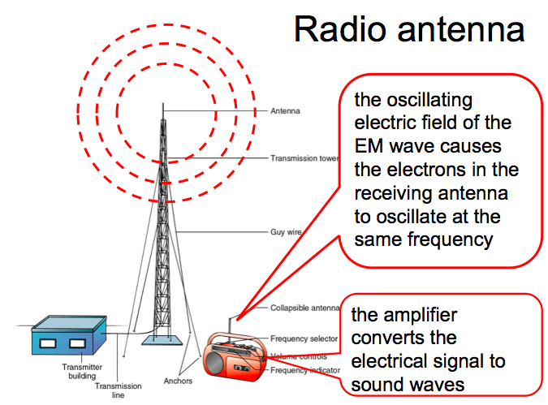

- The EM wave propagates through space and when it meets an antenna, its changing magnetic and electric fields have an influence on the electrons in the antenna – causing them to move.
- This is electromagnetic induction
- The oscillating electric and magnetic fields of an incoming radio wave exert force on the electrons in the antenna elements, causing them to move back and forth, creating oscillating currents in the antenna.
- An antenna tuned the correct frequency will cause resonance in the wire.
- The frequency at which these electrons oscillate is the same as the driving frequency.

- Different parts of the EM spectrum have different frequencies because of the different oscillating frequencies that create them.

- All EMR’s are produced by similar processes. Oscillating charged particles produce EMR that propagates through space to a receiver that has its charged particle move due to the electric and magnetic fields.

- Different EMR’s are produced by the different frequency at which charged particles can vibrate.

- High frequency EMR (gamma) is created by rapidly oscillating charged particles.

Application, Risks and Benefits:
Region | Production | Applications | Risks
Radio Waves | Oscillating electrons in wires | Communication | Unknown
Microwaves | Magnetron – high frequency electrons | Cooking, radar, telecommunications | Some cell damage
Infra Red | Oscillating electrons in molecules or atoms | Remote controls, night vision, camera auto focus | Cause heating
Visible | Oscillating electrons in molecules or atoms | Photography, vision | unknown
Ultra Violet | Oscillating electrons in molecules or atoms | Special lighting | Cause of skin cancer, sunburn and alters cell structure
X-rays | Rapidly decelerating electrons | Medicine, finding leaks in pipes, tracing fatigue in metals | Cause cancer and damage cells
Gamma Rays | Oscillation of charges within nuclei | Production of radioisotopes | Cause cancer and damage cells

PP 7.31 p 254-8 7.3 Review p259

Atomic phenomena and the interaction of light with matter indicate that states of matter and energy are quantised into discrete values.

- Light is part of the electromagnetic spectrum and is known to have wave-like properties.
- However, it able to travel through a vacuum, so it is not described as a mechanical wave.

- The current theory of electromagnetic radiation is that it has both wave-like and particle-like properties.

- Low energy EMR seems to be mostly wave-like while high energy EMR seems to be more particle-like.

- In 1901, Max Planck first proposed the idea that light is made up of small packets or bundles of energy called quanta.
- Planck was describing the EM radiation released by hot objects – black body radiation.
- The radiation has a specific spectrum and intensity that depends only on the temperature of the body.

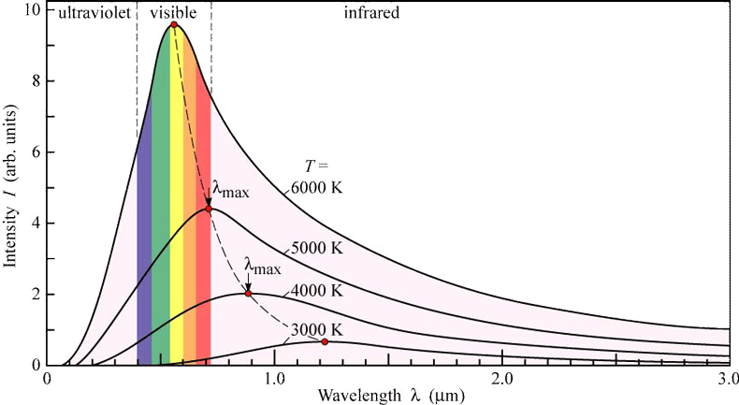

- Planck proposed that the radiation from the hot body was not continuous but is made up from discrete bundles of energy.
  - He proposed that atoms oscillate with specific energies.
  - When energy is gained or lost by an atom, it does so in discrete chunks.
- The energy of a bundle of energy was proportional to its frequency. E = hf

The Quantum Concept

- The quantum concept states that energy is present in small, discrete bundle.

- For example:
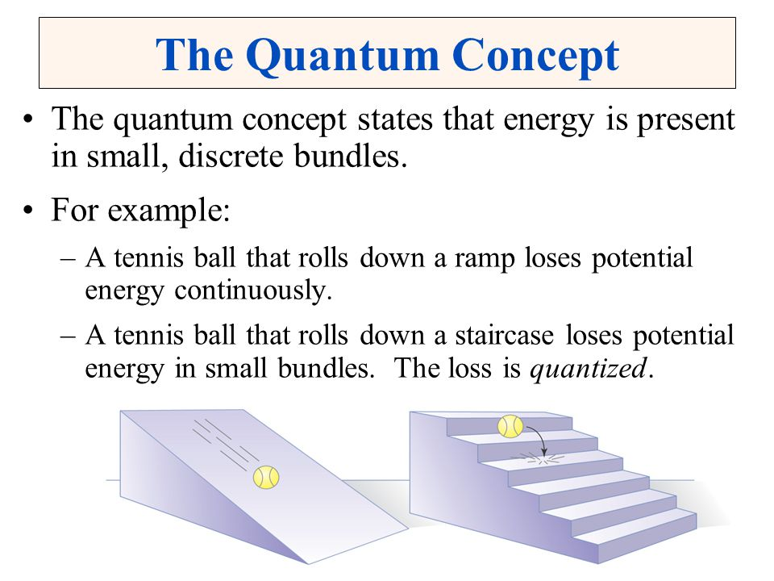
  - A tennis ball that rolls down a hill loses potential energy continuously.
  - A tennis ball that rolls down a staircase loses potential energy in small bundles. The loss is quantised.

- The radiation spectrum shown above appears to be a continuous curve.
- This is a hypothetical situation. In reality, the curve is made up from many individual lines that appear to merge into a continuous line.
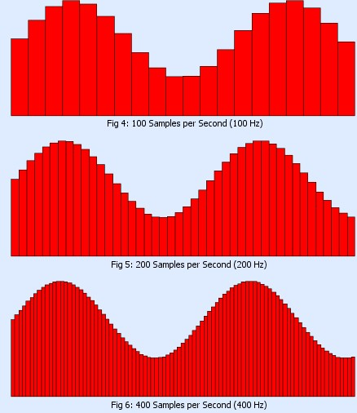

On the atomic level, electromagnetic radiation is emitted or absorbed in discrete packets called photons. The energy of a photon is proportional to its frequency. The constant of proportionality, Planck’s constant, can be determined experimentally using the photoelectric effect and the threshold voltage of coloured LEDs
This includes applying the relationships
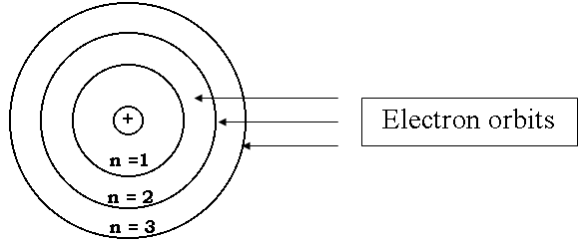
- In the simple atomic model, the nucleus is made up of protons and neutrons surrounded by electrons.
- The electrons orbit the nucleus in specific shells.
- Electrons are able to move from shell to shell by gaining or losing energy.

- Electrons are able to move to higher energy levels by gaining energy.
- When electrons fall to lower energy levels they release energy.

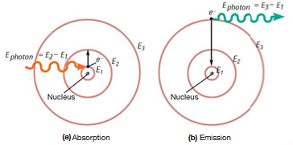

- The amount of energy gained or lost is an exact amount – a quantum of energy.

- When a quantum of light energy is released is has particle-like properties. It is referred to as a photon.
- Each photon has an exact amount of energy, called a quantum of energy. The energy of the photon is related to its frequency.
- Higher frequencies of EMR will have photons of higher energy.
- The amount of energy can be calculated using the formula

E = hf where E = photon energy (J)
h = Planck’s constant – 6.63 x 10⁻³⁴ (Js)
f = frequency of the photon (Hz)

Since c = f λ, the equation can be written as $E= \frac{hc}{λ}$ where c = speed of light = 3.00 x 10⁸ ms⁻¹
λ = wavelength of photon (m)

- The light from a yellow light globe has a typical wavelength of 580 nm. Determine the energy of each photon of yellow light emitted by the globe.

- Devices that generate EMR such as light globes, lasers, microwaves ovens and radio transmission towers create a very high number of photons each second.
- If the power rating of the device is known, the number of photons generated can be calculated.

- A deep red 2.50 W laser produces photons with a wavelength of 650 nm. Determine:
- the energy of each photon.
- the number of photon produced each second.
- the intensity of the beam if it has an area of 2.00 x 10⁻⁵ m².
- the energy output for each pulse of the laser if a pulse lasts 650 ns.

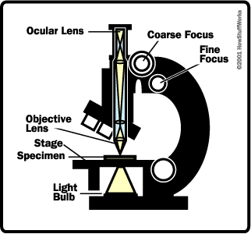
Electron microscope

- Light microscopes work by shining photons of light onto the surface of an object and examining the light that is reflected.
- The reflected light is channelled through various lenses and the image is observed.
- Visible light is usually defined as having wavelengths in the range of 400-700 nm. Light microscopes can’t distinguished details closer than 200 nm
- A human hair (~50 000 nm) is easily seen in an light microscope. A bacteria (~200 nm) or a protein (~10 nm) are difficult to see.

- There are essentially four important parts to an ordinary microscope:
  - The source of light.
  - The specimen.
  - The lenses that makes the specimen seem bigger.
  - The magnified image of the specimen that you see.

- To see finely detailed things that are "smaller than light" (smaller than the wavelength of photons), you need to use particles that have an even shorter wavelength than photons: in other words, you need to use electrons.

- An electron will also have a wavelength and can be used to produce images.
- For an electron with E_{K} of 1 eV the associated de Broglie wavelength is 1.23 nm. This is about 100 times smaller than a 1 eV photon.

- Electron microscopes produce mages using electrons that have wave properties, just as light does.
- Wavelengths of electrons are much smaller than visible light and much greater resolution and magnification can be achieved.
- In an electron microscope, these four things are slightly different.
  - The light source is replaced by a beam of very fast moving electrons.
  - The specimen usually has to be specially prepared and held inside a vacuum chamber from which the air has been pumped out (electrons do not travel very far in air).
  - The lenses are replaced by a series of coil-shaped electromagnets through which the electron beam travels. In an ordinary microscope, the glass lenses bend (or refract) the light beams passing through them to produce magnification. In an electron microscope, the coils bend the electron beams the same way.
  - The image is formed as a photograph (called an electron micrograph) or as an image on a TV screen.
Transmission electron microscope
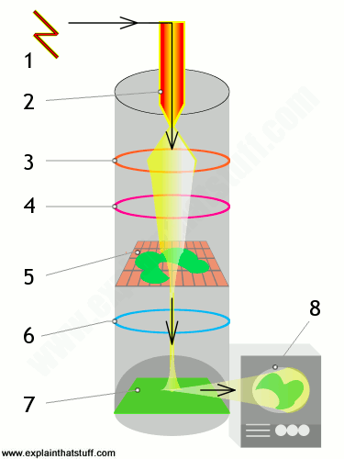
- High voltage power supply.
- Cathode generates a beam of electrons.
- Coils concentrate the electrons into a powerful beam.
- Coil focuses the beam onto a certain part of the specimen.
- Specimen sits on a grid in the middle of the microscope. The beam passes through the specimen and ‘picks up” an image of it.
- The projector lens magnifies the image.
- The image becomes visible when the electron beam hits a fluorescent screen – similar to an old fashioned TV.
- Image can be viewed directly, through binoculars or on a TV monitor.

Scanning electron microscope

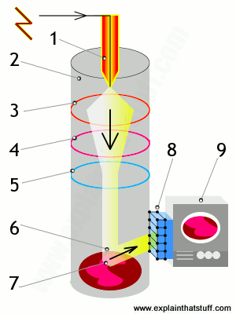
- Electrons are fired into the machine.
- Sealed vacuum – electrons can’t travel effectively through air.
- Positively charged electrode (anode) attracts electrons and accelerates them.
- A coil brings the electron beam into a precise focus – like a lens.
- Another coil steers the electron beam from side to side.
- The beam scans across the object.
- Electrons hit the surface and bounce off.
- A detector registers these scattered electrons and turns them into a picture.
- A magnified image is displayed on a TV screen.

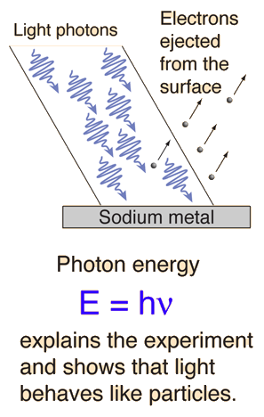
Photoelectric Effect.

- Over time, the theory of light has changed from a wave model to a particle model and back, due to various discoveries by scientists.
- In 1887, Heinrich Hertz was able to show that light had particle-like properties, which led to the reinstatement of the particle model.
- He, and others, showed that when light was shone onto a metallic surface, electron were ejected – the Photoelectric Effect.

- The photoelectric effect or photoemission is the production of electrons when light shines upon a material. Electrons emitted in this manner can be called photoelectrons.

- The photons of light can give the electrons enough energy to ionise them.

- An important consideration of the photoelectric effect is that electrons are not always ejected by light. Only light with enough energy can do this.
- The emission of the electrons is dependent on the frequency of the light.
- Since E = hf, the photon of light is related to its frequency – high frequency = high energy.

- The ejection of a photoelectron does not depend on the intensity of light. Bright light with a low frequency will not have enough energy to ionise an electron.

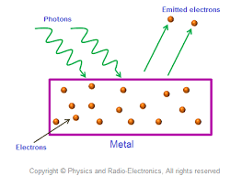
HOW IT WORKS

- Light of various frequencies and intensities is shone onto a cleaned metal surface in an evacuated tube.
- Frequency is changed until electron are released.
- A photocurrent is produced.

- Some of the observations of the Photoelectric Effect:
- electrons were only emitted when the frequency of light was above a certain value.
- this frequency is known as the threshold frequency, f₀.
- if f > f₀, electrons are emitted at the anode.
- Different metals have a different f₀.

- electrons were emitted immediately – no time lag.

- increasing the intensity of light increased the number of photoelectrons.
- brighter light = more photons = more electrons released
- their maximum kinetic energy did not change.

- higher frequency light releases electrons with more energy.
- red light did not cause the ejection of electrons, no matter what the intensity.
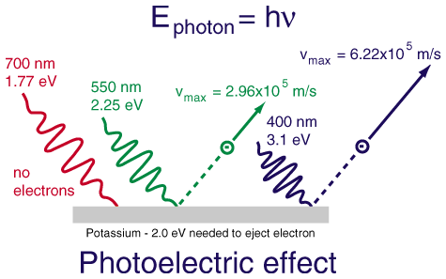
- weak violet light will eject only a few electrons, but their maximum kinetic energies are greater than those for intense light of longer wavelength.
E = hf

f>f₀
E = hf

f<f₀

- Philip Lenard is given credit for much of the early work on the photoelectric effect.
- His conclusions were:
- a photocurrent would only occur above a certain minimum frequency for each metal. This was called a threshold frequency.
- if light is not above the threshold frequency, no electrons are emitted, no matter how bright the light was.
- when a photocurrent was produced, higher intensity light produced more current.

- Analysis of the data for photoelectric experiment showed that the energy of an ejected electron was proportional to the frequency of the illuminating light.

- This supported the idea that the illuminating light is made up of photons that behave like particles.

- Each photon has a discrete amount of energy. E = hf.
- Higher frequency photons have more energy.

- Each electron needs a certain amount of energy to remove it.
- Photons with enough energy have a high enough frequency. This is the threshold frequency or cut-of frequency, f₀. The minimum energy required to remove an electron, E = hf₀.

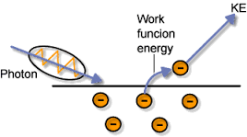
- This changes with each metal since some metals hold on to their electrons more strongly and is referred to as the work function, W. W = hf₀.
W

- The electron that is emitted will be released with a certain amount of kinetic energy. This will be equal to energy of the photon minus the work function.
E_{K} = hf – W

- Threshold frequency is defined as the minimum frequency of incident light which can cause photoelectric emission.
- Minimum amount of energy which is necessary to start photoelectric emission is called Work Function.
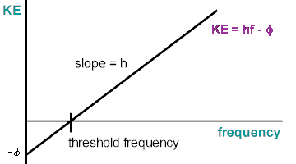
These frequencies do not cause emission

- Different metals have different work functions.
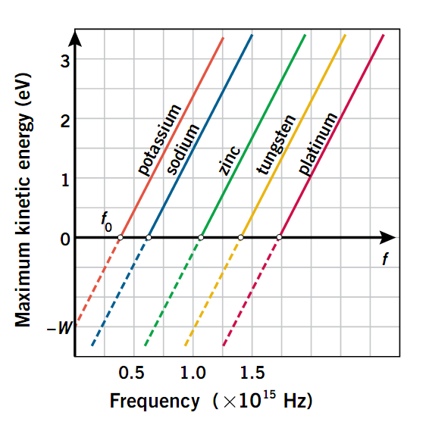

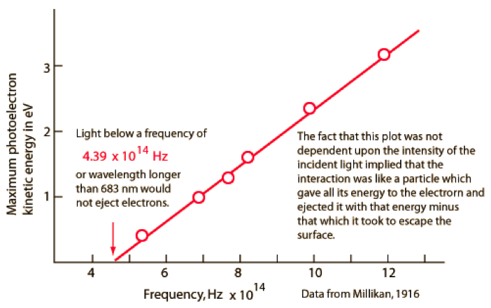

- NOTE:
- One photon will eject will eject one electron.
- The colour (frequency) of light determines its energy. (Violet higher energy than red)
Higher frequency of the photon = higher kinetic energy of the electron
- Bright light has more photons than dull light. (not photons with higher energy).
More photons (brighter light) = more electrons emitted
- Energy of a photon is transferred to an atom. Some energy is used to overcome the work function, the remainder is released as kinetic energy of the ejected electron.
- Low frequency light, less than W, will not release electron.

- The photoelectric effect cannot be explained by the wave theory of light.
- Wave theory would predict that the PE effect should occur at any frequency of light.
- Wave theory would predict that an increase in intensity would increase the kinetic energy of the electrons emitted.

- Ultraviolet light of 410 nm shines on a clean surface of calcium metal. The work function for calcium is 2.87 eV. Show that photoelectrons will be emitted from the surface.

- Calculate the maximum kinetic energy of the emitted electrons.

- Calculate the maximum velocity of the emitted electrons.

- When photoelectrons are released, they move from the negative terminal (cathode) to the positive terminal (anode). If a negative voltage is applied to the equipment, the current is slowed down. If the negative voltage is large enough, the electrons will stop – no current. This voltage is known as the ‘stopping voltage’.

- Photoelectrons are ejected from the surface of magnesium metal by light whose wavelength is 275 nm. It is found that the photoelectron current can be reduced to zero by applying a ‘stopping voltage’ of at least 0.860 V.
Determine the energy of the incident photons in J and eV.

- Determine the maximum kinetic energy of the photoelectrons.

- Determine the work function of the magnesium metal.

- Determine the threshold frequency of the metal.
(At the threshold frequency, the electrons are able to be dislodged but will have zero kinetic energy and are unable to leave the surface of the metal.)

- Using the graph, find the value of the work function for caesium. Give your answer in electron volts and joules.
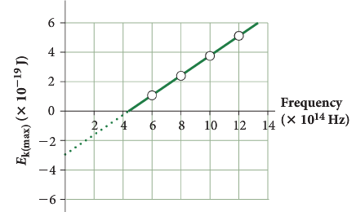

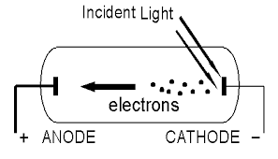

Stopping voltage

- A circuit can be set up to analyse the photocurrent produced.

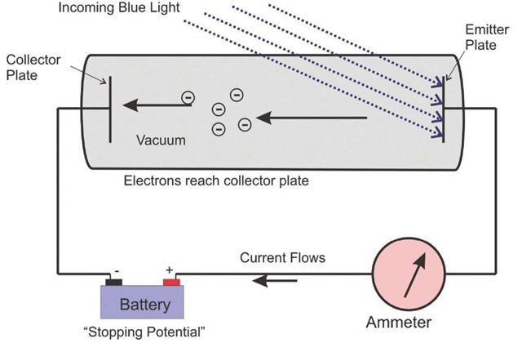
- With a –ve cathode and a +ve anode, a forward bias is produced.
- electrons are given assistance to accelerate towards the anode.

- With a +ve cathode and a –ve anode, a reverse bias is produced.
- electrons are repelled by the anode and slow down.

- As the voltage is increased, less photoelectrons make it to the anode. Less photocurrent is detected by the ammeter.

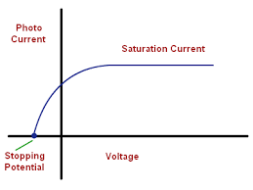
- Eventually, the voltage is increased to a point where no photoelectrons are detected.
- This is called the stopping voltage.

- Stopping voltage is equivalent to the maximum kinetic energy of a photoelectron.

- Photoelectrons with a kinetic energy of 2.96 x 10⁻¹⁹ J are stopped by using the apparatus above. What stopping voltage is required?

PP 7.4 264-8
WSG p106-11

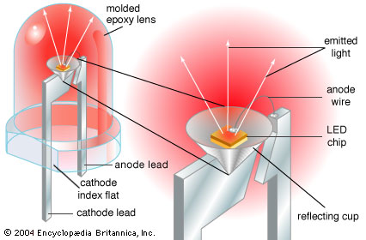
Coloured LEDs

- LEDs are light emitting diodes.
- Diodes are electronic devices that allow current to flow in one direction only.
- Light emitting diodes are diodes that emit light when current flows through them.
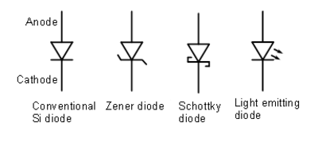


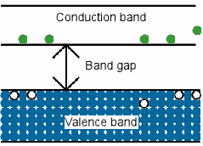
- LEDs will only emit light when the external applied voltage that is used to push the current through the diode is above a minimum threshold value.
E = hf
W = Vq
- W = Vq

- Electrons that receive sufficient energy lose their energy and emit photons of light of a certain wavelength (colour).
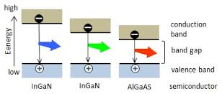
E = hf. This is equal to the initial amount of energy received by the electron.

- The colour of the light is determined by the energy of the photon and can be changed by using different materials in the LED.
- Each colour of LED has a different threshold voltage at which electrons start being produced. Measuring this voltage, together with known values for the emission wavelengths, provides a path to finding a value for the Planck constant.
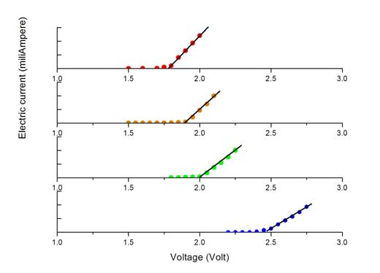

LED colour | Typical wavelength λ (nm) |  | Activation voltage, V_{a} (V)
Red | 623 |  | 1.78
Orange | 586 |  | 1.90
Green | 567 |  | 2.00
Blue | 470 |  | 2.45

- Using the equations $E_{ph}= \frac{hc}{λ}$ and $E= Vq$ combines to give $V= \frac{h c }{q λ}$ .

- Use the slope of the graph to calculate Planck’s constant, h.

V (volts)
$\frac{1 }{λ}$ (m⁻¹) (x 10⁶)
2.5
1.60
1.5
2.0
2.00
2.40

PP 7.5 p 279-81 WSG p122

Wave-particle duality

- Light has shown to display both wave-like characteristics
- reflection
- refraction
- diffraction
- polarisation
- dispersion
- interference

and particle-like characteristics

- reflection
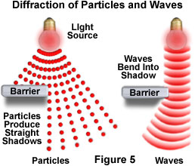
- refraction
- photoelectric effect

- Many properties of light can be explained with the wave theory or the particle theory, but neither theory can explain all properties.
- Waves can diffract around barriers.
- Diffraction of light cannot be explained by particle theory.
- Light interference patterns cannot be explained by particle theory.
- Polarisation is convincing evidence that light is a wave.

- Photoelectric effect cannot be explained by wave theory.

- Quantum theory (the idea that energy is made of small packets of energy called quanta) is based on the principle that matter and energy behave both as particles and as waves

- In 1924, Louis de Broglie first proposed an idea that particles might behave like waves.
- His idea was that if light waves can have particle-like properties then it is possible that particles can have wave-like properties.

- It has been shown that fast moving particles, like electrons, are able to diffract. Electron beams fired at crystals created diffraction patterns.
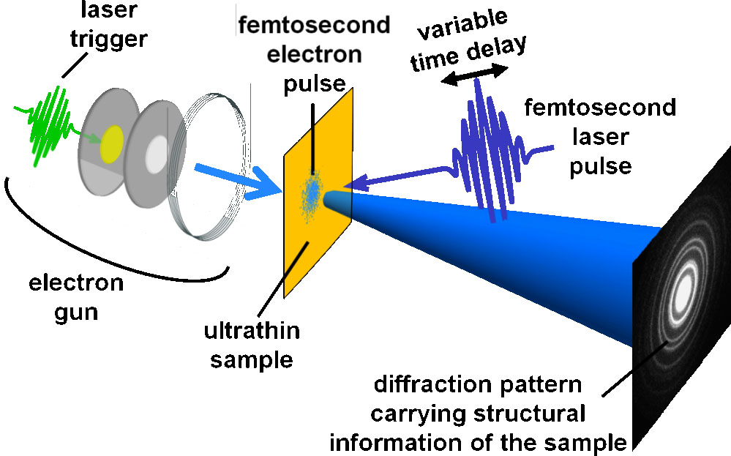

- Diffraction is a property of wave, suggesting that electrons (particles) can behave like waves.
- As such, they will have a wavelength. The de Broglie equation for the wavelength of a particle is given by:

$λ= \frac{h}{p}= \frac{h}{mv}$ where = wavelength (m)
h = Planck’s constant
p = momentum of particle (kg ms⁻¹)
m = mass (kg)
v = velocity (ms⁻¹)

- Every object has a de Broglie wavelength.
a) electron moving at 2.0 x 10⁸ ms⁻¹ , λ = 3.6 x 10⁻¹² m ( X-ray region = detectable).
b) 50 kg girl moving at 5.0 ms⁻¹ , λ = 2.7 x 10⁻³⁶ m (undetectable).
c) 50 g bullet moving at 250 ms⁻¹ , λ = 5.3 x 10⁻³⁵ m (undetectable).

- Determine the de Broglie wavelength of an electron moving at 0.010 c.

- Everyday objects will also have wavelengths associated with them. Determine the de Broglie wavelength of a 58.0 g tennis ball with a speed of 25 ms⁻¹.

- Explain how different types of electromagnetic radiation are produced.

- What is the speed of all electromagnetic radiation?
- Explain the dual nature of electromagnetic radiation.

- What is a photon?

- Which is more wave-like, gamma ray or microwaves?
- Where would you find high energy electromagnetic radiation?

- Light is both a wave and a particle. However, it can behave as one or the other depending on what observations or measurements are made.

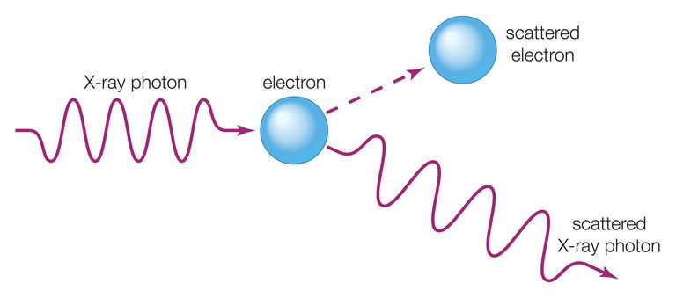
Compton Effect

- High energy photons shined onto a target can release an electron.
- The scattered radiation experiences a wavelength shift.
- This can’t be explained by Classical Wave theory. It relates to Einstien’s photon theory

A wide range of phenomena, including black body radiation and the photoelectric effect, are explained using the concept of light quanta.

WSG p112-3

Blackbody radiation

- Any object with a temperature above absolute zero emits various wavelengths of EMR.
- If the object is perfectly black (so it doesn't reflect any light), then the light that comes from it is called blackbody radiation.

- The energy of blackbody radiation is not shared evenly by all wavelengths of light.
- The spectrum of blackbody radiation (below) shows that some wavelengths get more energy than others.
- Four spectra are shown, for four different temperatures.
- The surface temperature of the Sun is ~5770 K.


- The blackbody spectrum depends only on the temperature of the object, and not on what it is made of.
- An iron horseshoe, a ceramic vase, and a piece of charcoal --- all emit the same blackbody spectrum if their temperatures are the same.

- As the temperature of an object increases, it emits more blackbody energy at all wavelengths.
  - More energy is emitted, creating a larger region on the graph.
  - More energy is emitted at shorter wavelengths.
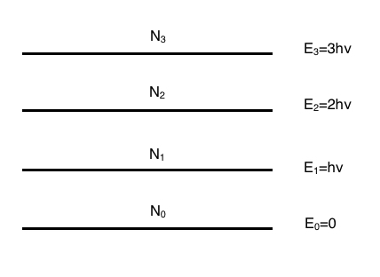
  - IR red orange yellow white blue.

- Atoms, when heated are made to oscillate. They can only oscillate at specific frequencies.
  - When they lose energy, the energy released is a result of atoms losing specific amounts of energy as they go to a lower oscillating frequency.
  - This energy is quantised.
  - Difference between energy levels is hf.
Planck modelled blackbody radiation as a series of harmonic oscillators with equally spaced energy levels.
- At higher temperatures, atoms are more energetic and can release a larger spectrum of EMR when they become de-excited.

- As the temperature of an object increases, the peak wavelength of the blackbody spectrum becomes shorter (bluer). For example, blue stars are hotter than red stars.
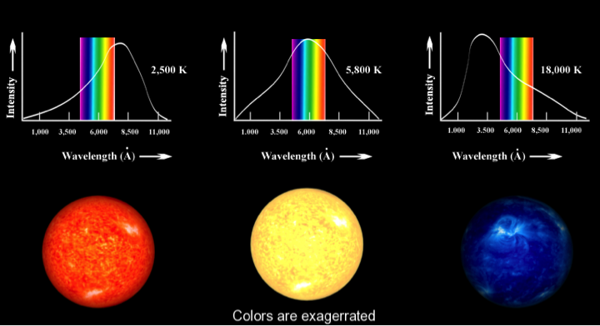

- The blackbody spectrum always becomes small at the left-hand side (the short wavelength, high frequency side).

- The explanation of classical physics:
- Light is an electromagnetic wave that is produced when an electric charge vibrates.
- In a hot object, electrons vibrate in random directions and produce light as a result.
- A hotter object means more energetic vibrations and so more light is emitted by a hotter object --- it glows brighter.
- Classical physics could not explain the shape of the blackbody spectrum.

- The shape of a Black Body Radiation curve is quite complex.

- As the temperature of the black body increases, the peak wavelength decreases.



- In the late 1800’s it was thought that heat energy was due to vibrating particles in an object. Higher temperatures create more vibrations that should lead to higher energy photons being released with shorter wavelengths.

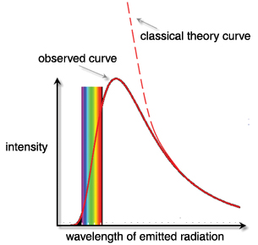

- In reality, a different curve is observed.

ULTRAVIOLET CATASTROPHE

- Classical model predicts that as the temperature rises, particles move faster and greater vibrations release higher frequencies of emitted radiation.
- The model would suggest that if an object gets hot enough, it should release very high frequencies - X-rays or gamma rays.
- In reality, this does not occur. Very hot objects do not release energy beyond UV. Physicists at the time could not explain this and became known as the “ultraviolet catastrophe”.

- It is now known that EMR is released (in the form of photons) when excited electrons move from high energy orbits to lower electron orbits.
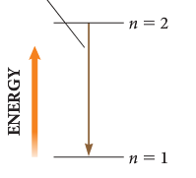
- Energy levels in atoms are finite.
- Therefore, the amount of energy of a photon is limited to the difference in energy levels between the highest and lowest levels.

- For the short wavelengths (UV), there is a large jump for electrons moving from one energy level to another. Less electrons in an excited state means lower number of photons and less intensity.

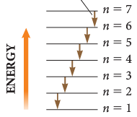

- For the longer wavelengths, there are many transitions possible but each has low energy. This leads to lower intensity.

- In the middle, there are more transitions and higher intensity.

- In about 1900, Max Planck came up with the solution.
- He proposed that the classical idea that each frequency of vibration should have the same energy must be wrong.
- His theory made a radical assumption that
“the energy of oscillations of atoms within molecules cannot have just any value; instead each has an energy which is a multiple of a minimum value related to the frequency of oscillation.”

- Planck said that energy comes in clumps. He called a clump of energy a quantum.
- The size of a clump of energy, a quantum, depends on the frequency of vibration.
- E = hf where h, the calibration constant, is today called Planck's constant.

- So how does this explain the spectrum of blackbody radiation?
- Planck said that an electron vibrating with a frequency f could only have an energy of 1 hf, 2 hf, 3 hf, 4 hf, ...
- E = nhf
- This meant that energy of oscillation was quantised – exists in discrete amounts (not continuous).
- Analogy – a guitar can be played over a continuous range, a piano is “quantised”.

PP 7.4 p 260-4

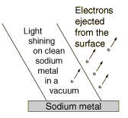
The Photoelectric Effect

- When light shines on the surface of a metallic substance, electrons in the metal absorb the energy of the light and they can escape from the metal's surface.
- This is called the photoelectric effect, and it is used to produce the electric current that runs many solar-powered devices.
- Using the idea that light is a wave with the energy distributed evenly throughout the wave, classical physicists expected that when using very dim light, it would take some time for enough light energy to build up to eject an electron from a metallic surface.
- Experiments show that if light of a certain frequency can eject electrons from a metal, it makes no difference how dim the light is. There is never a time delay.
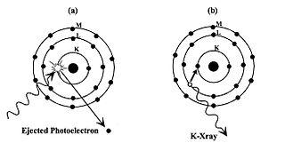
- In 1905, Albert Einstein came up with the solution.
- If Max Planck's idea that energy comes in clumps (quanta) is correct, then light must consist of a stream of clumps of energy.
- Each clump of light energy is called a photon, said Einstein, and each photon has an energy equal to hf (Planck's constant times the frequency of the light).
- Therefore the energy of light is not evenly distributed along the wave, but is concentrated in the photons.
- A dimmer light means fewer photons, but simply turning down the light (without changing its frequency) does not alter the energy of an individual photon.
- So for a specific frequency light, if a single photon has enough energy to eject an electron from a metallic surface, then electrons will always be ejected immediately after the light is turned on and the photons hit the metal.

PE Effect shows light is a particle.

- If dim light is shined onto the metal surface, wave theory would suggest that the metal atom would continuously absorb energy over time until the electron gained enough energy to be released.
- This doesn’t happen.
- More light makes no difference.

- However, if frequency increases to a certain value, electron are immediately released.

- This suggests that electrons absorb a “quantum” of energy and get emitted.
- A photon is like a particle with a fixed amount of energy, similar to a particle.
- One photon releases one electron.

7.4 Review p 269-70
Atoms of an element emit and absorb specific wavelengths of light that are unique to that element; this is the basis of spectral analysis
This includes applying the relationships

SPECTRA
Producing an Optical Spectrum

- In the 17th century Isaac Newton discovered that sunlight could be dispersed into its component colours by catching a shaft of light and passing it through a glass prism.

- It works because each wavelength has a different refractive index for the glass and so they bend at progressively different angles according to Snell's Law. All waves exhibit refraction.
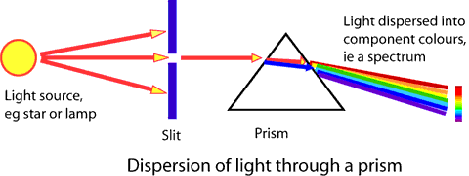
white

Type of Spectra
- Spectra are classified into two main types, emission and absorption spectra. The essential difference in the two types of spectra is the means by which it was produced in the first place.
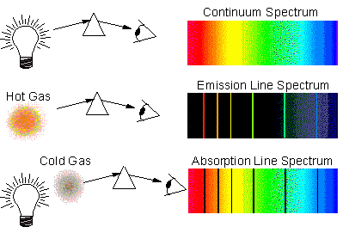
- Emission spectra are that which is obtained by the dispersion of light coming directly from the source.
- This may be from the glowing gas in a discharge tube or an incandescent (glowing) solid such as a globe filament.
- From an astronomical point of view, these are the emissions formed from hot nebulae, quasars

- Absorption spectra are that which is obtained by the dispersion of light that has passed through some absorbing material.
- In this type of spectra we see black lines superimposed onto a continuous spectrum which represents the absence of light within the spectrum.
- The solar spectrum contains a series of black lines in an otherwise continuous spectrum.

Emission Spectra
- Emission spectra may be either line emission, band emission or continuous emission. This type of spectra is from cold nebulae, atmospheres of stars.

- Line emission – thin distinct lines of colour on black background due to distinct frequencies of atoms.
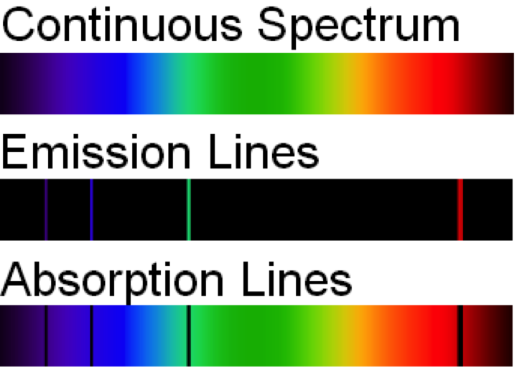

Each element has its own distinct line emission spectrum – it can be used to identify the element.

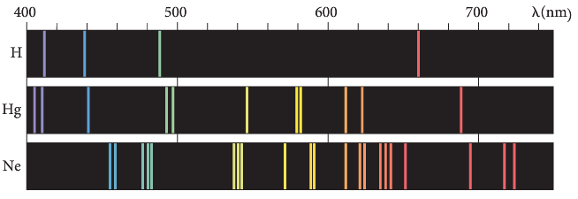
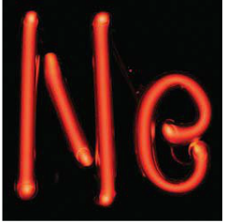

- Band emission- produces bands of thin lines due to excitement of molecules rather than atoms

- Continuous emission – light from hot incandescent solids produces a continuous spectrum including the surfaces of stars and hot, solid metals.

Absorption Spectra

- Absorption spectra may be either line or band absorption.

- Line absorption – when white light is passed through a vapour or some low pressure gas, photons of the frequencies corresponding to the line emission spectrum of that gas will be absorbed. This means that black lines (or an absence of light) will be seen where bright lines would have appeared in an emission spectrum.


- The solar spectrum is an example and the black lines correspond to the emission lines of gases in the sun’s outer atmosphere and to some extent the earth’s atmosphere. These lines are called Fraunhofer lines.
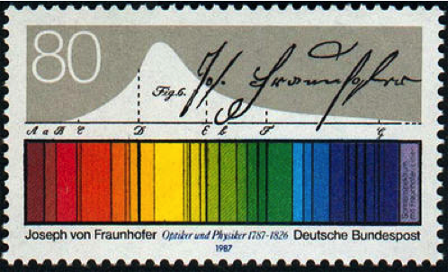

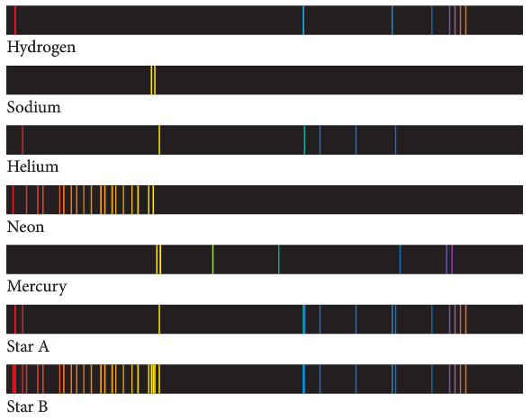
- Absorption spectra can be used as a forensic tool. By comparing the spectrum of an unknown sample with spectra of known elements, it is possible to determine the composition of elements in the unknown sample.

- Every atom has distinct energy levels and therefore has a unique line emission spectrum.
- This can be used to identify the element.

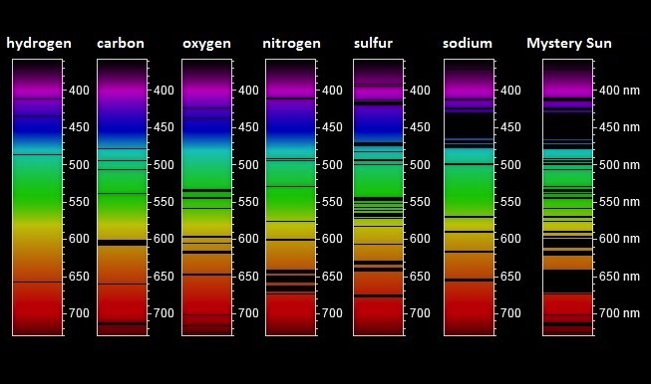

- Band absorption – similar to line absorption when light passes through coloured glass or coloured liquid solutions. Light is absorbed by atoms bound in molecules.
- Dark bands are visible within an otherwise continuous spectrum.



- The emission spectrum and the absorption spectrum for hydrogen are shown below. The wavelengths for the absorption and the emission are exactly the same. This makes sense because these lines are associated with exact transitions between energy levels in the hydrogen atom.

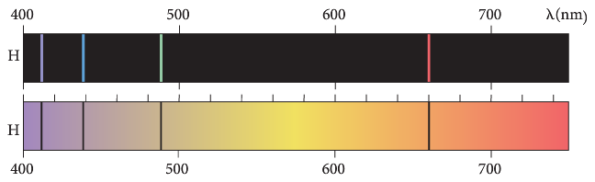

The Bohr model of the hydrogen atom integrates light quanta and atomic energy states to explain the specific wavelengths in the hydrogen spectrum and in the spectra of other simple atoms; the Bohr model enables line spectra to be correlated with atomic energy-level diagrams.

Spectra of Gases and Bohr’s Model of the Atom

Problems with pre Einstein Physics
- Electrons are charged particles moving in circular motion, therefore according to classical physics (prior to 19th century)
- accelerating charges must generate electromagnetic radiation
- energy is sent off into space
- therefore atom should collapse but obviously did not.

- No explanation for spectrum emitted by a gas excited by an electric current
- gases consisted of separate frequencies e.g. hydrogen, instead of continuous frequency e.g. sun

- 1905 Einstein solved many of these problems by two papers that revised existing theories and laid the ground for Modern Physics.

Particle-like nature of electromagnetic radiation
- When light shines on a material, electrons can be ejected from the surface into the space above. This is called the photoelectric effect. What is happening is that “particles of light” called photons, with sufficient energy collide with electrons in the material.

Line Emission Spectrum.

- When hydrogen gas is excited (energy added by heat, e⁻ bombardment or photon absorption), coloured lines on black background can be seen when the hydrogen is looked at using a spectrometer. These lines corresponded to certain frequencies only and were different for different gases.

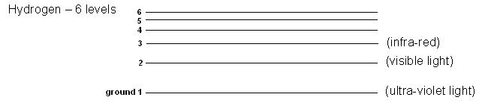
lowest energy state

- Studies found that the lines were due to the electrons being excited and jumping to higher energy levels. They quickly returned to their original level by releasing the energy given to them in the form of electromagnet radiation.

- Depending on the amount of energy, different frequencies of light were emitted and hence the different colours. From the energy level diagram above, it can be seen that if an electron falls to level 3, it gives out infra-red light, level 2 is visible light, and level 1 is ultra-violet light.

- Line emission spectrums were explained by Bohr using hydrogen gas.

- While other gases tend to be more complex (more electrons to gain and lose energy), the basic theory generally holds true.

The Bohr Model Of The Hydrogen Atom

- Niels Bohr put forward a theory concerning the structure of the atom. His theory helps physicists to better understand the behaviour of electrons within an atom.

Main Ideas

- Hydrogen atom consists of a positive nucleus with one negative electron orbiting.
- Quantum hypothesis – electrons only exist in definite and discrete orbits of particular energy (known as their ground state), although an electron can move temporarily to a higher orbit if given exactly the right amount of energy.
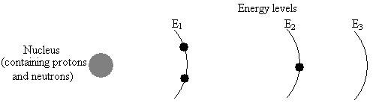
Note: E₂ is a higher energy than E₁ as it is further from the nucleus.

- Energy emitted when electron return to a lower level from a higher level. Frequency of energy determined by difference in energy level.

E₂ - E₁ = hf Where E₂ = initial higher energy level
E₁ = final energy level
h = Planck’s constant
f = frequency
hf
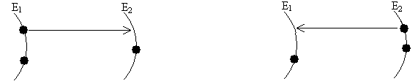
Energy is required to ‘excite’ electron in ground state to higher energy level.
Energy released as E.M. radiation when returning to ground state.

- Excited electrons moving from high energy levels to lower energy levels undergo acceleration and deceleration – they release a photon of EMR (package of energy).
- Bohr’s model accounts for coloured spectral lines produced by hydrogen.
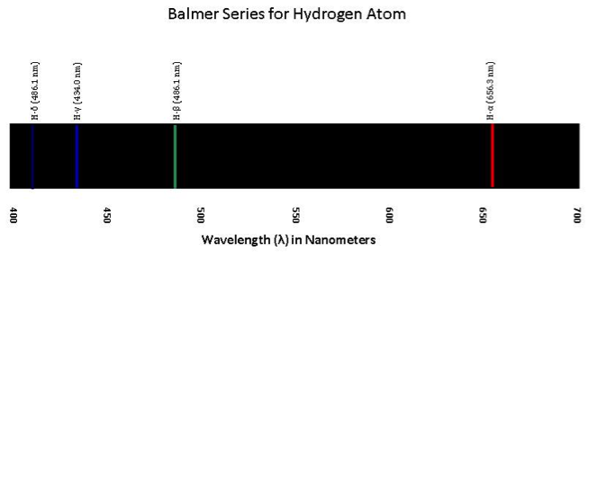

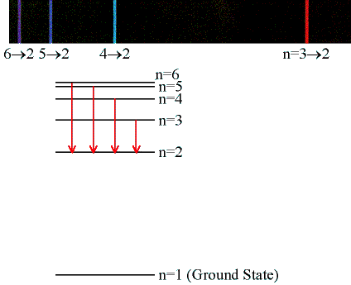
- A hydrogen atom can be represented with six energy levels.

- Only four transitions result in visible light, those ending in the second level.



- Transitions ending in level 3 produce infra-red radiation and level one produce ultra-violet radiation.
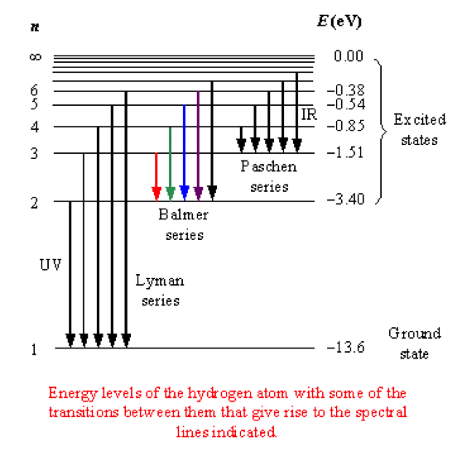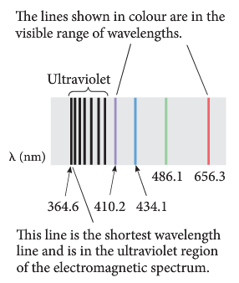

- Atoms absorb energy to excite electrons. These electrons can only stay excited for a short time and return to lower states, releasing photons.

Loss of electron – occurs when the electron is excited beyond energy levels.
ionization

E₃

E₂
energy input
Energy transitions – energy is released when the electron returns to ground state.


E₁

(ground state)

Relationships
- As electromagnetic radiation is wave-like, wave formula applies:

v = λ f or c = λ f where c = speed of wave = 3.0 x 10⁸ m s⁻¹
λ = wavelength in metres (m)
f = frequency in hertz (Hz)

- Occasionally you have to deal with intensity of light beam. The intensity is the energy transferred per square metre per second:

I = E where I = intensity in W m⁻²
At E = energy (J)
A = area (m²)
t = time (s)

- Each photon of electromagnetic radiation has its own characteristic frequency called a quantum of energy. This characteristic frequency can be found using the formula

E = hf where E = energy in joules
h = Planck’s constant = 6.63 x 10⁻³⁴ J s
f = frequency in hertz (Hz)
NOTE:
- Energy input can be in the form of heat, electron bombardment or photon excitation.
- When an electron bombards an atom, it loses some its kinetic energy as an electron in the tom gets excited. The amount of energy lost during the bombardment is equal the gain of energy during excitation.
- Photon excitation requires exact quantities of energy. If the incoming photon does not possess the exact energy for a transition, the excitation will not occur.

Example:
A local radio station transmits signals at a frequency of 92.9 MHz.
a. Calculate the energy of each photon produced.
b. If the power output of the radio signal is 1.2 kW, how many photons per second are transmitted?

Answer a:
E = hf
= 6.63 x 10⁻³⁴ x 92.9 x 10⁶
= 6.16 x 10⁻²⁶ J

Answer b:
P = 1200 W = 1200 joules per second
i.e. 6.16 x 10⁻²⁶ J represents 1 photon
1200 J represents x photons
= 1.95 x 10²⁸ photons per second.

- Light of wavelength 4.53 x 10⁻⁷ m is emitted when an electron moves from an energy level of 6.89 x 10⁻¹⁹ J to another energy level closer to the ground state. What is the energy of this level?

Interpretation of Line Emission Spectra
Loss of electron – occurs when the electron is excited beyond energy levels.

ionisation level up here



photon = hf₁
excitation states
E₃

E₂
photon = hf₂
Incoming e⁻
or heat
or photon
E₁

Energy transitions – energy is released when the electron returns to ground state.

- electrons are usually at ground state
- electron given energy and jumps to higher level – this is when electron is in excited state.
- on return to ground state releases energy (as photon of electromagnetic radiation)
- energy is usually stated in electron volts (eV) → 1 eV = 1.60 x 10⁻¹⁹ J
- energy is given as a negative value (e.g. E₁ = -13.6 eV). The negative sign indicates lower energy level than one above.
- Energy released is given by E₃
different levels.
- Formulae E = hf and v = fλ
E _{released} = E₃ – E₁ E₂

E _{released} = E₂ – E₁
E₁ E₁

- Note that energy level diagrams can be presented in two ways.
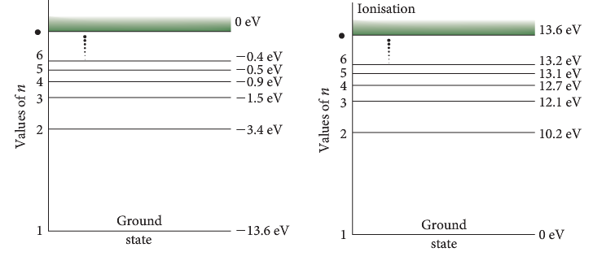
- When calculating the energy for a particular transition, the difference in two energy levels will be the same.
- For E₂ to E₃ 12.1 – 10.2 = 1.9 eV or 3.4 – 1.5 = 1.9 eV

Some Important Terminology

Ground State
Excited Atom
Photon
Quantum
Energy level
Ionisation energy

- NOTE: if an electron bombards an atom, it can give up some of its energy to excite another electron, then bounce off with less E_{K}. If a photon bombards an atom, it must have an exact amount of energy, equivalent to the energy level change, to cause excitation. If a photon has energy in excess of the ionisation energy, an electron will be removed from the atom = Photo Electric Effect.

- Line emission spectra are created by single atoms in elements.
- Electrons transition between discrete energy levels.
- One possible transition produces a single LINE.
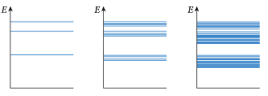

1 atom 4 bound atoms many bound atoms

- Band emission spectra are created by molecules.
- When more than one atom is bound together, energy level merge together and create the band emission and absorption spectra associated with molecules.
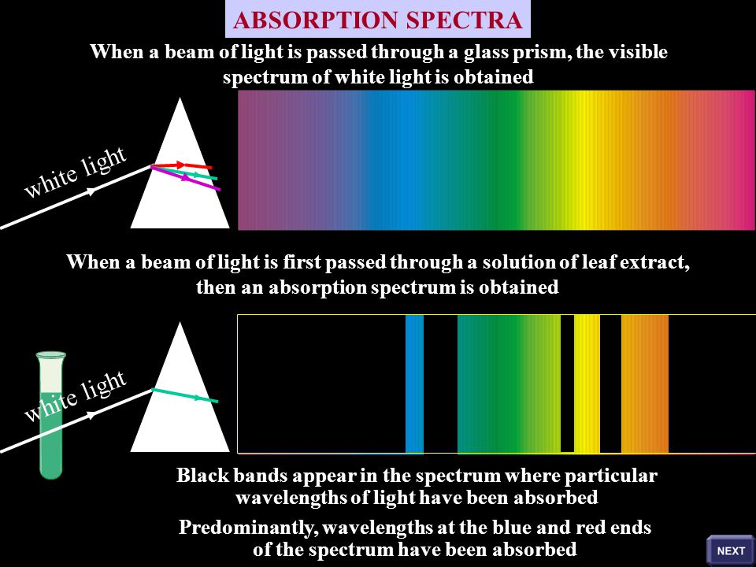
- Overlapping electron clouds.
- Several transitions together produce a BAND.

- Continuous emission occurs in very hot substances.
- Many transitions produce many wavelengths of light.
- Hot metals have overlapping electron clouds, creating many possible transitions.

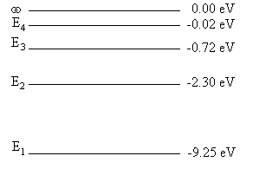
- The following diagram represents the energy levels possible for a particular atom.
- How many possible energy transitions are there?
- What is the significance of the ∞ energy level?
- Which transition will give the
  - lowest frequency?
  - Shortest wavelength?
- Use the electromagnetic spectrum to determine the type of electromagnetic radiation emitted in (i) and (ii) above.

PP 7.5 p 271-9 7.5 Review p 284
WSG p113-21

Applications of Spectra

Excitation by photons – Fluorescence
- Fluorescence is the emission of electromagnetic radiation light by a substance that has absorbed radiation of a different wavelength.

- Generally, the absorption of light of a certain wavelength results in the emission of light with a longer wavelength and lower energy.

- In fluorescence, the emission and absorption follow each other quite rapidly, so that fluorescence lasts only as long as the illuminating radiation is on. The excited electrons are not in a stable state and return to the ground state immediately.

- In phosphorescence, however, the emission occurs quite slowly and persists for a long time after the illuminating radiation has been turned off. The excited electrons are reasonably stable and return to the ground state over a period of time after the source has been removed.
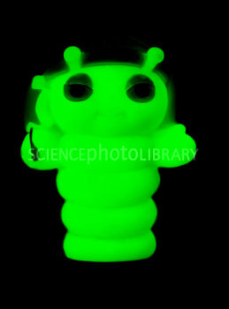
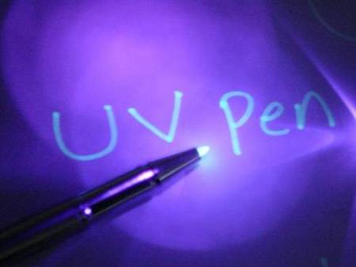

- Fluorescent materials often emit light without a significant change in temperature. The diagram below shows the process of fluorescence.

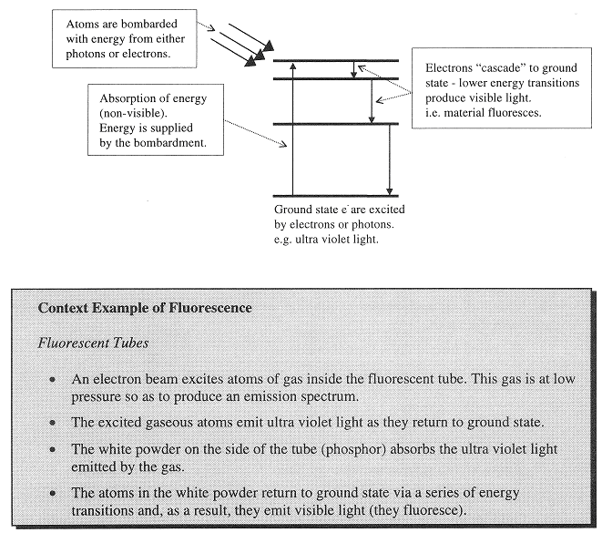

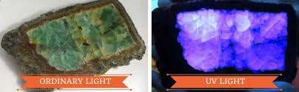

A common example of fluorescence – fluorescent tubes.

  - An electron beam excites atoms of the gas inside the fluorescent tube. This gas is at a low pressure so as to produce an emission spectrum.
  - The excited gaseous atoms emit ultra violet light as they return to their ground state.
  - The white powder on the side of the tube (phosphor) absorbs the ultra violet light emitted by the gas.
  - The atoms in the white powder return to their ground state via a series of energy transitions and, as a result, they emit visible light – in other words, they fluoresce.

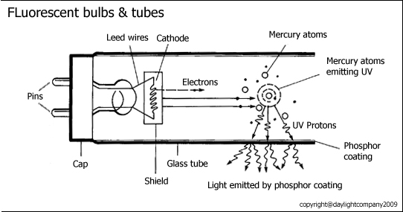
- Questions on Fluorescence:
1. Explain how fluorescence works.

2. In your own words, explain how a fluorescence tube works

3. Explain why fluorescence is used in fluorescent ink.

4. Some soap powders are claimed to clean “whiter than white”. Explain why they might make the
material appear to be very white.

WSG p121

Excitation by electrons – X-rays

Generation of X-rays:
- X-rays are high frequency electromagnetic waves (or photons) which are produced when high speed electrons strike a metal target.

- They were first discovered by Roentgen in 1895 while experimenting with a discharge tube. He realised that they were some kind of very penetrating ray but knew little else about them and so decided to call them X-rays.

- X-rays are produced in an X-ray tube where:
- electrons are heated and then accelerated to very high velocities by voltages of about 50kV.
- the electrons strike a metal target anode (often copper or tungsten)
- the potential energy from the electrical supply results in the electrons gaining kinetic energy
- they strike the target emitting photons in the X-ray region.
- electrons also lose energy during these collisions forming a wide low intensity emission called bremsstrahlung (braking radiation).
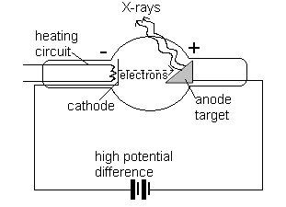
The cathode is a source of electrons when heated. Once produced , the electrons are accelerated through a large potential difference (approximately 50kV) towards the anode target. | The anode target is made of copper and tungsten (to prevent melting). Electrons from the cathode are rapidly decelerated as they collide with the atoms in the anode. These collisions produce X-rays. The electrons undergo several collisions with target atoms resulting in different wavelength X-rays being produced.

- X-rays are high frequency electromagnetic radiation (dangerous in long exposures).
• X-rays have both high energy and strong penetrating powers and are produced in an X-ray tube.
- Although the rapidly decelerating electrons produce X-rays, the majority of the electrons’ kinetic energy is converted to heat energy during the collisions.

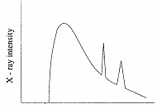
- While giving up their energy, the electrons can undergo several collision within the metal anode target.

- As a result, several photons of different energies are produced.

- The diagram shows characteristic peaks of an X-ray spectrum from an X-ray tube which are related to the type of atoms in the metal.
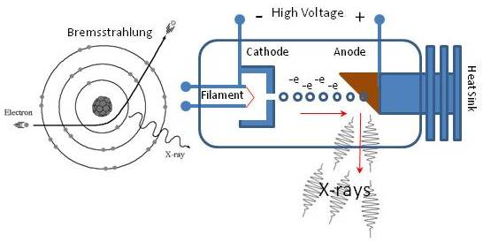
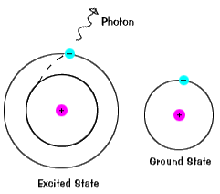

To summarise X-rays are generation:
- Heated filament emits electrons
- Very high PD across cathode and anode
- Electrons accelerate quickly towards anode target
- Rapid deceleration when they hit target means energy converted to X-rays
- Two types of X-rays
  - as described above
  - spikes in ionise electrons in dense materials

- Electrons in an x-ray tube are accelerated towards a metal target by a voltage of 45.0 kV. Determine the maximum kinetic energy attained by the electrons.
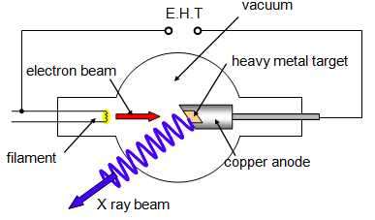

- Determine the velocity of the electrons as they reach the target

- Determine the momentum and wavelength of the electrons as they reach the target.

- In TV & CRO screens, bombarding electrons strike a special chemical coating called a phosphor. Phosphor atoms are excited and then proceed to undergo downward energy level transitions giving off visible light. This light has to escape in about 1/25 of a second.

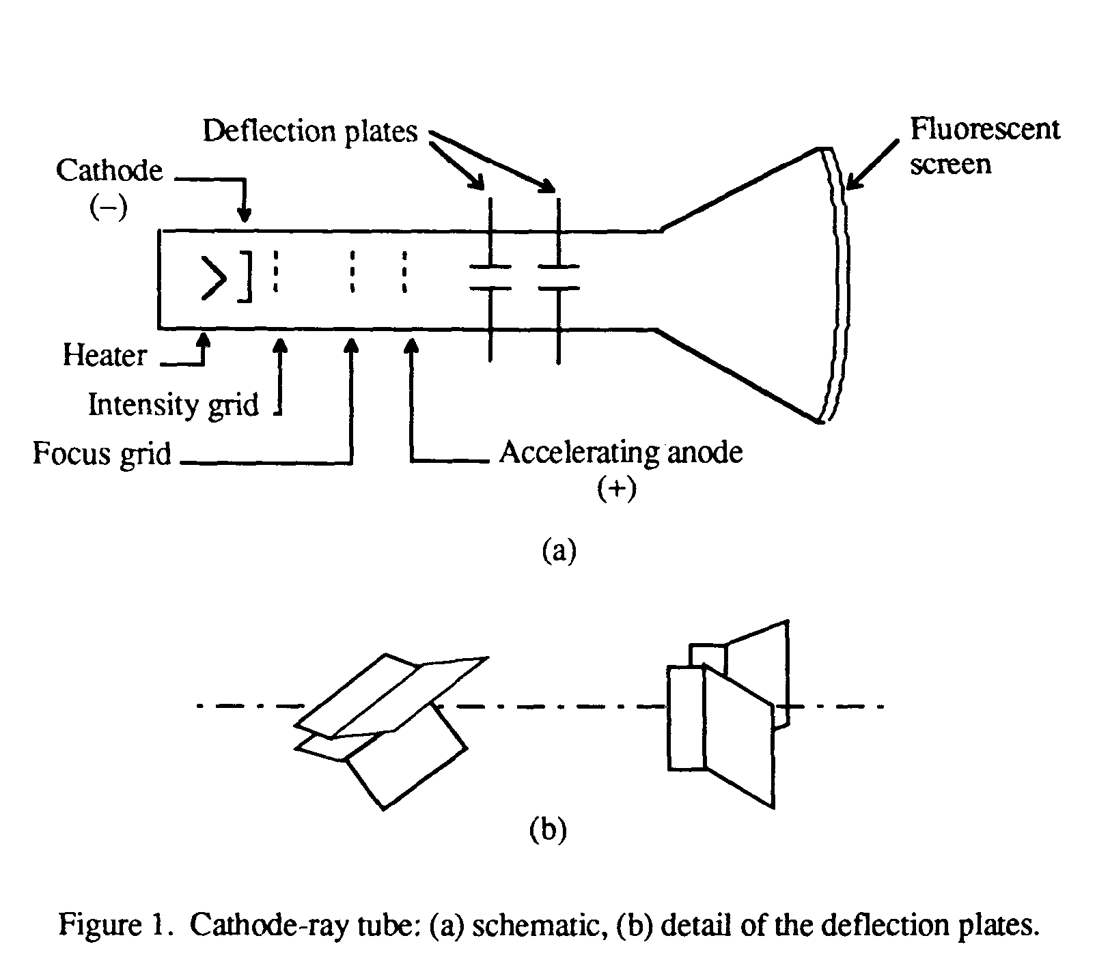

- Coloured glowing signs such as neon (red)
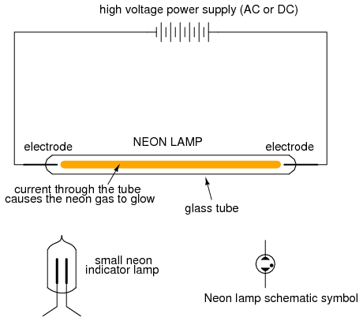

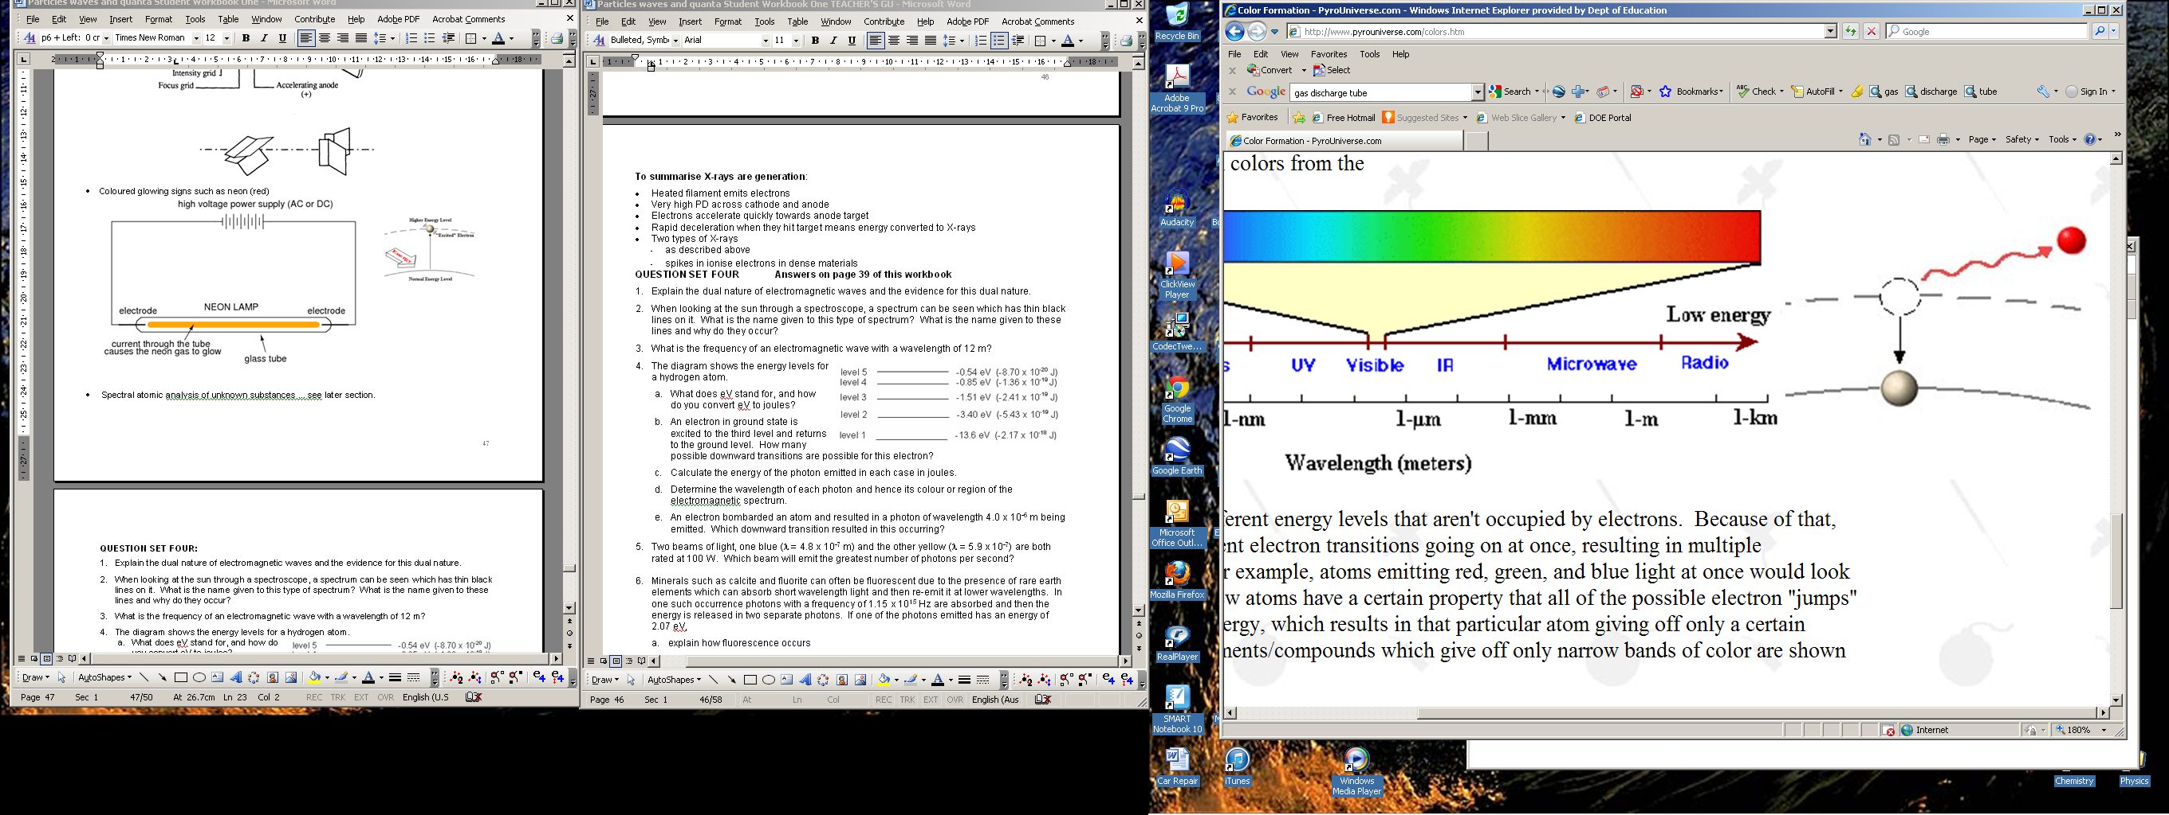
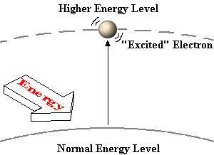

WSG p123-4

de Broglie waves and the Bohr atom

- Transitions of electrons between orbits in an atom are associated with exact amounts of energy.

- This suggests that each electron orbit has an exact radius.

- The dual nature of light suggests that particles, like electrons, have a wave nature associated with them and, hence, will have a wavelength.
- When the idea of electrons having a de Broglie wavelength is applied to the Bohr atom, it reinforces that energy levels are quantised.

- Each orbit of an electron has a wave nature and each orbit is considered to be a standing wave.

- Only certain orbits are possible. If the electrons form a wave, then an integer number of wavelengths must fit into the orbit.

- The conditions for a stable orbit is given by: nλ = 2πr

  - 2πr is the circumference of the orbit, nλ must fit into the circumference
  - λ = the de Broglie wavelength of the electron orbit
  - n = 1,2,3,4,…
  - r = radius of the orbit

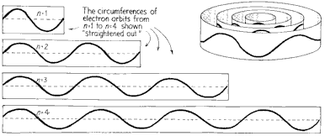
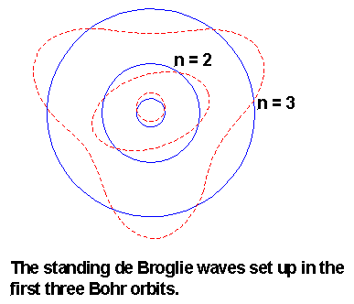

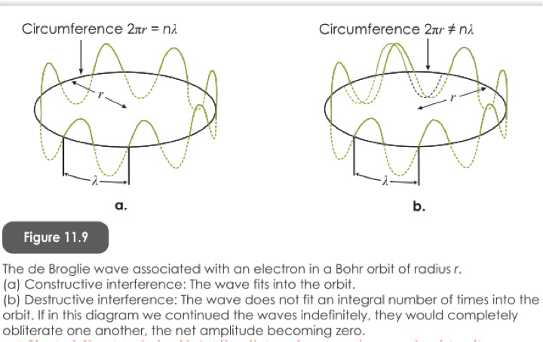

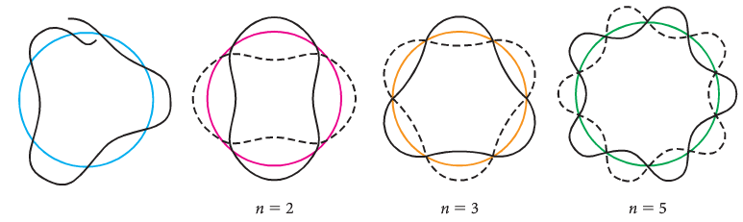
not a standing wave stable orbits

- Calculate the wavelength associated with an electron orbiting a hydrogen atom in its ground state. The radius of the lowest orbit is 5.29177 x 10⁻¹¹ m.

PP 7.6 p 286-90

LASERs

- Lasers are devices that produce narrow, intense beams of light.
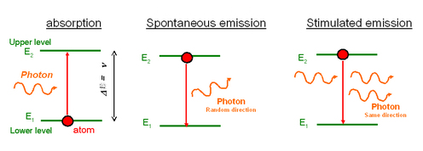
- The light beams are monochromatic (one colour, one frequency) and coherent (all parts of the wave are in phase).

- We have already seen that electrons can be promoted to higher energy levels by absorbing an exact frequency of light, corresponding to E = hf.



- If an electron is in an excited state, it can spontaneously drop to a lower state and release a photon of light in the process.



- However, if a photon of light with the same energy strikes the excited atom, it can stimulate the electron to drop to the lower level.
- This process is called stimulated emission.

- Two photons are released, the one that caused the emission and the one that is emitted.

- They are exactly in phase and they are moving in the same direction.
- That is, coherent light is produced by the laser.
- Laser stands for Light Amplification by Stimulated Emission of Radiation.

- The first process to produce laser light is to excite the atoms.
- Normally, most atoms have electrons in lower states. Shining light onto these atoms will cause most of the photons to be absorbed.
- Atoms are initially excited by strong flashes of light of a specific wavelength, e.g 550 nm.
- This creates what is known as an inverted population.
- The second factor relates to excited electrons being in a metastable state, the electron remain excited longer than usual – they need to be stimulated to drop, not drop spontaneously.

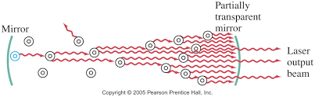

- An initial atom becomes de-excited and releases a photon. This causes an avalanche of photons to be released.

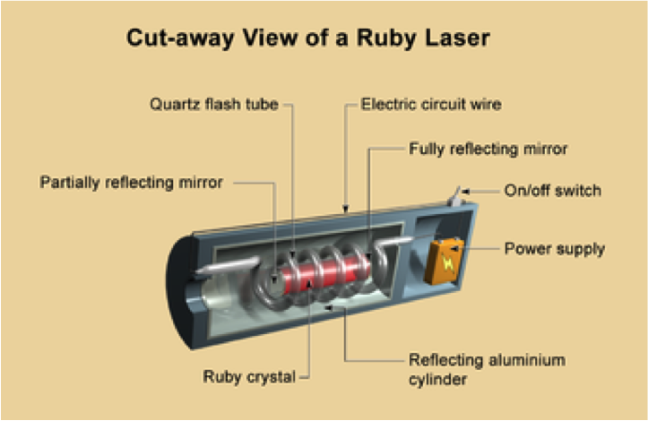

PP 7.5 p 281-3

QUESTION SET TWO: Answers on page 57

- What name is given to the lowest energy level?
- What is meant by saying that an electron is in an excited state?
- There are six levels in the hydrogen atom: -13.6 eV, -3.40 eV, -1.51 eV, -0.85 eV, -0.54 eV, -0.48 eV. Explain why the energies are given as negative numbers. What would happen if more than 13.6 eV were added to the electron? What name do we give to this occurrence?
- If the hydrogen atom in question 4 was in an excited state with an electron at the E₃ level, what would be the highest frequency photon it could emit as it returned to the ground state?
- What is the frequency, wavelength and’ colour of the light emitted when ‘an electron moves from a level of energy equal to 8.43 x 10⁻¹⁹ J to an energy level of 3.95 x 10⁻¹⁹J?
- The first three energy levels of an atom are at 1.98 x 10⁻¹⁹J, 4.86 x 10⁻¹⁹J and 8.65 x 10⁻¹⁹J. An electron transition results in the release of a photon of frequency 5.72 x 10¹⁴ Hz. Between which energy levels did the electron move?
- The electron in a hydrogen atom can exist at various energy levels, E1:ground state, 0.700 x 10⁻¹⁹ J, E2: 17.0x 10⁻¹⁹J, E3: 20.0x 10⁻¹⁹J and E4: 21.8 x 10⁻¹⁹J.
  - How many lines in the emission spectrum of atomic hydrogen can be predicted? Draw them.
  - Of all these lines, which has the shortest wavelength and what is this wavelength? What type of radiation is this?
- The wavelength of a blue line in the Balmer series of the hydrogen spectrum is 4.34 x 10⁻¹⁷ m. Given in electron volts, what is the energy difference between the two energy levels responsible for this line?
- A ship building company uses a powerful laser to cut steel plate. The laser has a power of 900.0 W and produces infra red radiation with a wavelength of 1.00 x 10⁻⁶ m.
  - What is the energy per photon produced?
  - How many photons are produced per second?
QUESTION SET THREE Answers on page 59

- Explain the dual nature of electromagnetic waves and the evidence for this dual nature.

- When looking at the sun through a spectroscope, a spectrum can be seen which has thin black lines on it. What is the name given to this type of spectrum? What is the name given to these lines and why do they occur?

- What is the frequency of an electromagnetic wave with a wavelength of 12 m?

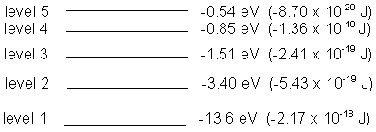
- The diagram shows the energy levels for a hydrogen atom.
- What does eV stand for, and how do you convert eV to joules?
- An electron in ground state is excited to the third level and returns to the ground level. How many possible downward transitions are possible for this electron?
- Calculate the energy of the photon emitted in each case in joules.
- Determine the wavelength of each photon and hence its colour or region of the
electromagnetic spectrum.
- An electron bombarded an atom and resulted in a photon of wavelength 4.0 x 10⁻⁶ m being emitted. Which downward transition resulted in this occurring?

- Two beams of light, one blue (λ = 4.8 x 10⁻⁷ m) and the other yellow (λ = 5.9 x 10⁻⁷) are both rated at 100 W. Which beam will emit the greatest number of photons per second?

- Minerals such as calcite and fluorite can often be fluorescent due to the presence of rare earth elements which can absorb short wavelength light and then re-emit it at lower wavelengths. In one such occurrence photons with a frequency of 1.15 x 10¹⁵ Hz are absorbed and then the energy is released in two separate photons. If one of the photons emitted has an energy of 2.07 eV,
- explain how fluorescence occurs
- determine the energy of the other photon emitted
- determine the wavelengths of the two photons emitted
- determine the part of the electromagnetic spectrum or colour that these photons belong to.
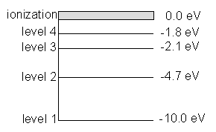
- Look at the energy level diagram below of a particular atom:
- Why are the energy levels shown as negative?
- Assuming that the electron doesn’t ionize, how many downward transitions are possible? Show them on the diagram.
- What type of radiation is produced when an electron moves from level 4 to level 3?
- How much radiation is needed for the electron to ionize?
- What is the wavelength of a photon produced when an electron at ground state is excited to level 2 and returns.
- A photon of energy 12.5 eV enters the atom in the ground state. How much energy is used to ionize the atom and what would be the velocity of the ejected electron?
On the atomic level, energy and matter exhibit the characteristics of both waves and particles. Young’s double slit experiment is explained with a wave model but produces the same interference and diffraction patterns when one photon at a time or one electron at a time are passed through the slits.

- In 1801 Thomas Young was able to offer some very strong evidence to support the wave model of light.
- He placed a screen that had two slits cut into it in front of a monochromatic (single colour) light.
- The results of Young's Double Slit Experiment should be very different if light is a wave or a particle.

- If light is a particle, then only the couple of rays of light that hit exactly where the slits are will be able to pass through.
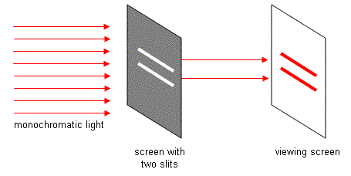
- An analogy would be to consider as though we are spraying paint from a spray can through the openings.
- Since they are little particles they will make a pattern of two exact lines on the viewing screen

- If light is a wave, everything starts the same way, but results we get are very different.
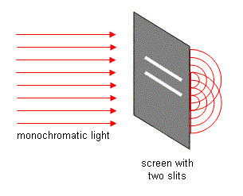
- There are still only two light rays that actually go through the slits, but as soon as they pass through they start to diffract.
- Diffraction is when light passes through a small opening and starts to spread out. This will happen from both openings.

- Notice that at some points the two sets of waves will meet crest to crest, at other spots crest meets trough.
- Where crest meets crest, there will be constructive interference and the waves will make it to the viewing screen as a bright spot.
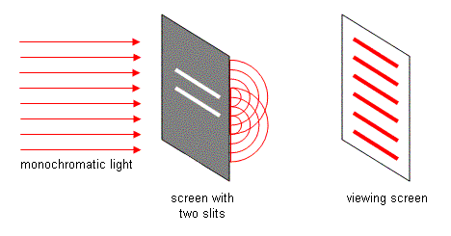
- Where crest meets trough there will be destructive interference that cancel each other out… a black spot will appear on the screen.

- When this experiment is performed we actually see this.

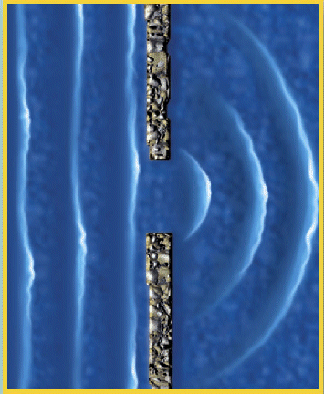
- It must be concluded that light is made up of waves, since particles cannot diffract.

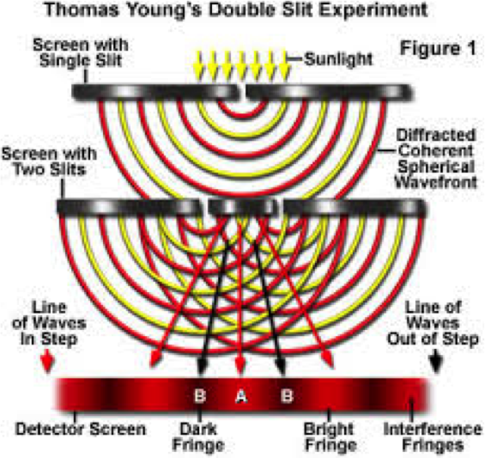

- There is always a middle line, which is the brightest. This is called it the central fringe.
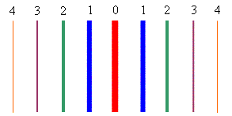

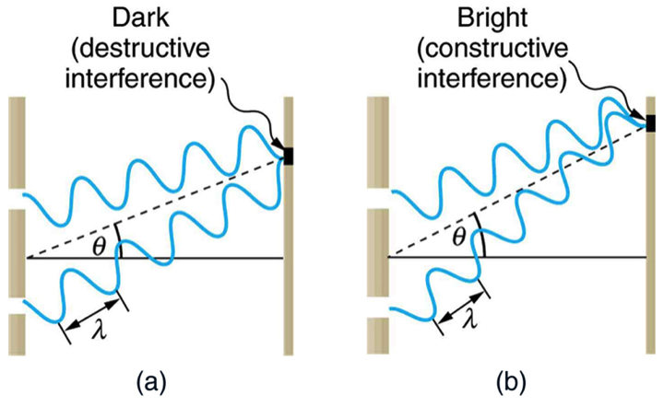

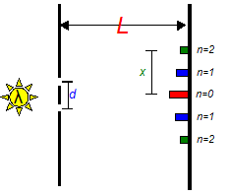

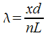

PP 7.2 p 248-52 7.2 Review p 253
PP 7.6 p 285-9 7.6 Review p 297 Chapter review p 298-301
WSG 3.1 p102-3

QUESTION SET ONE: Waves and Wave Behaviour. (Page 13)

- An umpire blows his whistle when he is at the opposite end of a football ground from you. Estimate the time delay between the moment you see the whistle being blown and when you hear it.
s = 100 m (between 100 and 200 m OK) v = s/t
v = 346 m s⁻¹ t = s/v
= 100/346
t = 0.29 s only 2 sf
(time for light about 3.33 x 10⁻⁷s so can ignore)
make sure you have no more than 2 significant figures in answer

- a. What does the term “displacement” mean when applied to sound waves (2000 TEE)
Distance from mean position of a vibrating object, amplitude of vibration.

b. Sketch graphs of displacement versus time for a low pitch graph and a high pitched graph.
The assumption is that the amplitude is the same so only the wavelength changes.
A high pitch sound has a high frequency say 10 000 Hz and a low pitch sound has a low frequency say 100 Hz.
A displacement vs time graph show period.
T (high) = 1/10 000 = 1 x 10⁻⁴ s while T (low) = 1/100 = 0.01 s
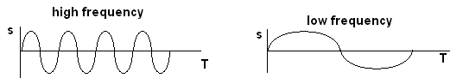

- Do sound waves diffract? If you wanted to try and demonstrate that your answer is correct, how would you try to do this? Include a diagram with your answer.
Sound waves do diffract e.g. standing beside an open door, hear what is happening inside. Here the wavelength is a similar size to the opening (door) so very small shadow region and large diffraction.

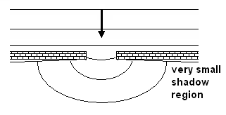
- Some examples of waves are sound, radio, water waves, and X-rays. Classify these as either mechanical or electromagnetic waves
Electromagnetic – radio and X-rays. Mechanical – sound and water waves

- A person fishing from jetty notices that the foam float on their fishing line gently bobs up and down as regular waves pass by. The person counts 13 full oscillations of the float in one minute. What is the period of the wave? (1998 TEE)
f = 13/60 T = 1/f = 1/0.217
= 0.217 s T = 4.6 s

- An example of a longitudinal wave is sound An example of a transverse wave is light
Explain the difference between longitudinal and transverse waves. (1998 TEE)
Vibrations in longitudinal waves are parallel to the progression of energy of the wave.
Vibration in transverse wave are perpendicular to progression of energy of the wave.
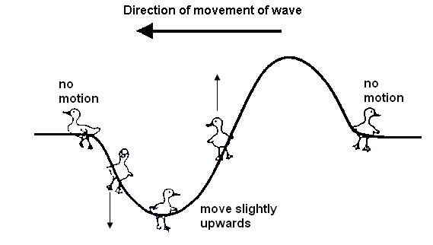
- Bridgette is watching some ducklings, which are paddling on a pond, when a wave approaches them. Use arrows to show direction of movement of each duckling at the instance shown on the diagram. If there is no movement, label “no-motion”.

- Draw a graph to illustrate amplitude and wavelength of a wave.
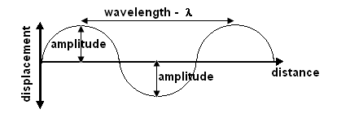

- Complete the following diagram to show reflection of sound from a circular reflector.

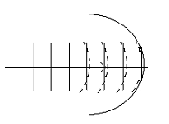

- On a calm summer evening the air near the ground is rather cool while higher up it is warmer. Sound travels faster in warm air. Using wave-front diagrams carefully show how refraction of sound can allow the noise from an aircraft to be heard quite clearly at some point far away.
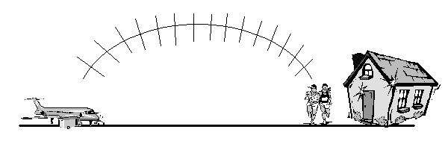
As cooler lower down, the sound bends away from the normal as it moves upwards from the aircraft as it moves faster in warmer air. This creates the bending effect.

QUESTION SET TWO (p 51)

- What name is given to the lowest energy level? ground state
- What is meant by saying that an electron is in an excited state?
The electron has received energy and is at a higher energy level than its ground state

- There are six levels in the hydrogen atom: -13.6 eV, -3.40 eV, -1.51 eV, -0.85 eV, -0.54 eV, -0.48 eV. Explain why the energies are given as negative numbers. What would happen if more than 13.6 eV were added to the electron? What name do we give to this occurrence?
0 E_{P}

Energies are given as negative number as energy needs to be
as e⁻ falls it loses energy – more negative
put in to raise the electron above its ground state. Also indicates
that the lower energy levels have less energy than the one above.

The electron would leave the atom – known as ionisation

- If the hydrogen atom in question 3 was in an excited state with an electron at the E₃ level, what would be the highest frequency photon it could emit as it returned to the ground state?

If at level 3, then can return straight to level 1. 13.6 – 1.51, so 12.09 eV can be given out.
E (J) = hf f = = 2.92 x 10¹⁵ Hz

- What is the frequency, wavelength and colour of the light emitted when an electron moves from a level of energy equal to 8.43 x 10⁻¹⁹ J to an energy level of 3.95 x 10⁻¹⁹J?

E₂ – E₁ = hf
8.43 x 10⁻¹⁹ - 3.95 x 10⁻¹⁹ = f x 6.63 x 10⁻³⁴
4.48 x 10⁻¹⁹ = f x 6.63 x 10⁻³⁴
f = 6.76 x 10¹⁴ Hz

λ =
= 4.43 x 10⁻⁷ m

colour = violet

- The first three energy levels of an atom are at 1.98 x 10⁻¹⁹J, 4.86 x 10⁻¹⁹J and 8.65 x 10⁻¹⁹J. An electron transition results in the release of a photon of frequency 5.72 x 10¹⁴ Hz. Between which energy levels did the electron move?

ΔE = 5.72 x 10¹⁴ x 6.63 x 10⁻³⁴
= 3.792 x 10⁻¹⁹ J

E₃ – E₂ = 8.65 x 10⁻¹⁹ – 4.86 x 10⁻¹⁹
= 3.79 x 10⁻¹⁹ J so energy levels are E₃ → E₂
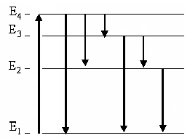
- The electron in a hydrogen atom can exist at various energy levels, E1:ground state, 0.700 x 10⁻¹⁹ J, E2: 17.0x 10⁻¹⁹J, E3: 20.0x 10⁻¹⁹J and E4: 21.8 x 10⁻¹⁹J.
  - How many lines in the emission spectrum of atomic hydrogen can be predicted for these four levels? Draw them.
six levels as shown

  - Of all these lines, which has the shortest wavelength and what is this wavelength? What type of radiation is this?

ΔE = as h & v constant, ΔE ∝ so smallest λ means largest ΔE ∴ E₄ → E₁

21.8 x 10⁻¹⁹ - 0.7 x 10⁻¹⁹ =
λ = = 9.43 x 10⁻⁸ m so UV

- The wavelength of a blue line in the Balmer series of the hydrogen spectrum is 4.34 x 10⁻⁷ m. Given in electron volts, what is the energy difference between the two energy levels responsible for this line?

E = 4.5829 x 10⁻¹⁹ J divide by 1.6 x 10⁻¹⁹

E = 2.86 eV

- A ship building company uses a powerful laser to cut steel plate. The laser has a power of 900.0 W and produces infra red radiation with a wavelength of 1.00 x 10⁻⁶ m.
  - What is the energy per photon produced?

E = 1.989 x 10⁻¹⁹ J

  - How many photons are produced per second?
E = P x t; t = 1.0 s so E = 900 J
number of photons =

= 4.52 x 10²¹ photons / sec

QUESTION SET THREE (p 52)

- Explain the dual nature of electromagnetic waves and the evidence for this dual nature.

Electromagnetic radiation exhibits both wave-like properties such as reflection, refraction and diffraction and explains Young’s Double Slit Diffraction experiment.
Also has particle-like properties such as the Photoelectric Effect where light of a particular frequency was able to eject a photon from a target metal to create an electric current. Particle like nature also shown by spectra.

- When looking at the sun through a spectroscope, a spectrum can be seen which has thin black lines on it. What is the name given to this type of spectrum? What is the name given to these lines and why do they occur?

Absorption spectrum: Fraunhofer lines.
Light from sun passes through sun and Earth’s atmospheres. Photons of frequencies corresponding to line emission spectrum of the atmospheres will be absorbed thus producing black lines in spectroscope. Thousands of lines have now been catalogued.

- What is the frequency of an electromagnetic wave with a wavelength of 12 m?

f = = 2.50 x 10⁷ Hz


- The diagram shows the energy levels for a hydrogen atom.
  - What does eV stand for, and how do you convert eV to joules?

eV stands for electron volt, a measure of energy.

1 eV = 1.6 x 10⁻¹⁹ J
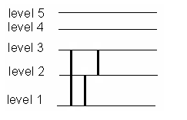
  - An electron in ground state is excited to the third level and returns to the ground level. How many possible downward transitions are possible for this electron?

three transitions

  - Calculate the energy of the photon emitted in each case in joules.

ΔE = E₃ – E₁ E₃ – E₂
= 21.7 x 10⁻¹⁹ – 2.41 x 10⁻¹⁹ 5.43 x 10⁻¹⁹ – 2.41 x 10⁻¹⁹ 21.7 x 10⁻¹⁹ – 5.43 x 10⁻¹⁹
= 19.29 x 10⁻¹⁹ J 3.02 x 10⁻¹⁹ J 16.27 x 10⁻¹⁹ J

  - Determine the wavelength of each photon and hence its colour or region of the electromagnetic spectrum.

= 1.03 x 10⁻⁷ m = 6.59 x 10⁻⁷ m = 1.22 x 10⁻⁷ m
UV visible - red UV

  - An electron bombarded an atom and resulted in a photon of wavelength 4.0 x 10⁻⁶ m being emitted. Which downward transition resulted in this occurring?
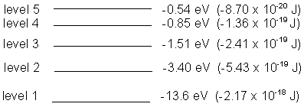
E = 4.9725 x 10⁻²⁰ J
= 0.31 eV
this is related to E₅ to E₄

- Two beams of light, one blue (λ = 4.8 x 10⁻⁷ m) and the other yellow (λ = 5.9 x 10⁻⁷) are both rated at 100 W. Which beam will emit the greatest number of photons per second?

E _{blue} = E _{yellow} =
= 4.144 x 10⁻¹⁹ J = 3.3712 x 10⁻¹⁹ J

P = , but for 1.0 s, work = E x t so power = energy

No. photons = No. photons =
= 2.41 x 10²⁰ = 2.97 x 10²⁰

so greater number of photons from yellow light.

- Minerals such as calcite and fluorite can often be fluorescent due to the presence of rare earth elements which can absorb short wavelength light and then re-emit it at lower wavelengths. In one such occurrence photons with a frequency of 1.15 x 10¹⁵ Hz are absorbed and then the energy is released in two separate photons. If one of the photons emitted has an energy of 2.07 eV
  - explain how fluorescence occurs

Mineral contains chemicals (phosphors) that appear to produce their own light. Phosphor absorbs non-visible light (e.g. UV) which excites electrons to a higher energy level. As electrons return to ground level they undergo a transition in the visible light range emitting frequencies of visible light.

  - determine the energy of the other photon emitted

E = fh E₁ = 2.07 x 1.6 x 10⁻¹⁹
= 1.15 x 10¹⁵ x 6.63 x 10⁻³⁴ = 3.312 x 10⁻¹⁹ J
= 7.6245 x 10⁻¹⁹ J

E₂ = 7.6245 x 10⁻¹⁹ - 3.312 x 10⁻¹⁹
= 4.3125 x 10⁻¹⁹ J energy of other photon is 4.3125 x 10⁻¹⁹ J

  - determine the wavelengths of the two photons emitted

= 6.01 x 10⁻⁷ m = 4.61 x 10⁻⁷ m

  - determine the part of the electromagnetic spectrum or colour that these photons belong to.

visible – orange visible - blue

- Look at the energy level diagram below of a particular atom:
- Why are the energy levels shown as negative?

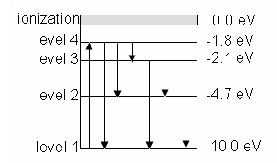
Electrons need to receive energy to move up levels

- Assuming that the electron doesn’t ionize, how many downward transitions are possible? Show them on the diagram.

6 transitions

- What type of radiation is produced when an electron moves from level 4 to level 3?

(2.1 – 1.8) x 1.6 x 10⁻¹⁹ = 6.63 x 10⁻³⁴ x f
f =
f = 7.24 x 10¹³ Hz so infra red radiation

- How much radiation is needed for the electron to ionize?

10 eV = 1.6 x 10⁻¹⁸ J

- What is the wavelength of a photon produced when an electron at ground state is excited to level 2 and returns.

ΔE = (10 – 4.7) x 1.6 x 10⁻¹⁹
= 8.48 x 10⁻¹⁹ J

λ = 2.35 x 10⁻⁷ m

- A photon of energy 12.5 eV enters the atom in the ground state. How much energy is used to ionize the atom and what would be the velocity of the ejected electron?

10 eV is used to ionise the atom.

(12.5 – 10) x 1.6 x 10⁻¹⁹
= 4.0 x 10⁻¹⁹ J is left to give the electron its velocity

E_{k} = ½ mv²
4.0 x 10⁻¹⁹ = 0.5 x 9.11 x 10⁻³¹ x v²
v =

v = 9.37 x 10⁵ m s⁻¹

